# **A**

# **REPORT**

**On**

# **WEB DEVELOPMENT**

*Submitted*

*In partial fulfilment*

*For the award of the Degree of*

|  |  |
| --- | --- |
| Submitted By:  M.AshwanthReddy (221710301023) | Submitted To:  Dhayanahita School of Professional Studies |

## **Department of Computer Science and Engineering**

**Candidate’s Declaration**

**(Name and Signature of Candidate)**

**Counter Signed by**

# **ACKNOWLEDGEMENT**

My project would not have been successful without the help of several people. I would like to thank the personalities who were part of my project in numerous ways, those who gave me outstanding support from the birth of the project.

I am extremely thankful to our honorable Pro-Vice-Chancellor, Prof. N. Siva Prasad for providing necessary infrastructure and resources for the accomplishment of my project.

I am highly indebted to Prof. N. Seetha Ramaiah, Principal, School of Technology, for his support during the tenure of the project.

I am very much obliged to our beloved Prof. S. Phani Kumar, Head of the Department of Computer Science & Engineering for providing the opportunity to undertake this project and encouragement in the completion of this project.

I hereby wish to express my deep sense of gratitude to Mr. Anil Kumar, for the esteemed guidance, moral support and invaluable advice provided by him for the success of the project.

I am also thankful to all the staff and mentors of the Dhyanahita School of Professional Studies who have cooperated in making my project a success. I would like to thank my parents and friends who extended their help, encouragement and moral support either directly or indirectly in my project work.

**Sincerely,**

**M.Ashwanth Reddy**

**(221710301033)**

**ABSTRACT**

**Table of Content**

|  |  |  |  |
| --- | --- | --- | --- |
|  | **Title** | | **Page No.** |
|  | List of Tables…………………………………………………….. | |  |
|  | List of Figures | |  |
| 1. | Introduction………………………………………………………  1.1 Objectives | | 8 |
| 2. | Web Development……………………………………………….. | | 9-10 |
|  | 2.1 | Web Site |  |
|  | 2.2 | Web Page |  |
| 3. | The Steps to Create a Web site…………………………………… | | 11-22 |
|  | 3.1 | UI development |  |
|  | 3.1.1 HTML | |  |
|  | 3.1.2 CSS | |  |
|  | 3.1.3 Bootstrap | |  |
|  | 3.2 | Scripting |  |
|  | 3.2.1 Server side scripting | |  |
|  | 3.2.2 Server side scripting languages | |  |
|  | 3.2.3 Client side scripting | |  |
|  | 3.3 | Database |  |
|  | 3.4 | SQL |  |
|  | 3.5 | Queries |  |
| 4. | Scripting Languages…………………………………………………………………… | | 23-27 |
|  | 4.1 | PHP |  |
|  | 4.2 | Installing PHP |  |
|  | 4.3 | Java Script |  |
|  | 4.4 | JQuery |  |
|  | 4.5 | AJAX |  |
|  | 4.6 | JSON |  |
|  | 4.7 | XAMPP |  |
|  | 4.8 | Features |  |
|  | 4.9 | Uses |  |
| 5. | Software Requirement Specification (SRS)………………….… | | 28 |
|  | 5.1 | Hardware Requirement |  |
|  | 5.2 | Software Requirement |  |
| 6. | Data Flow Diagram……………………………………………… | | 29-32 |

|  |  |  |  |
| --- | --- | --- | --- |
|  | 6.1 | DFD-1 |  |
|  | 6.2 | DFD-2 |  |
|  | 6.3 | DFD-3 |  |
| 7. | Project……………………………………………………………. | | 33 |
|  | 7.1 | Project(Advanced Technologies) |  |
|  | 7.2 | Technologies Used |  |
|  | 7.3 | Technical details |  |
| 8. | Screenshots………………………………………………………. | | 34-38 |
| 9. | Maintenance……………………………………………………… | | 39 |
| 10. | Future scope and future enhancement…………………………… | | 40 |
| 11. | Conclusion………………………………………………………. | | 41 |
|  | Bibliography | |  |

List of figures

**CHAPTER-1**

**INTRODUCTION**

The industry definition of a Full Stack Developer is an engineer who can work on different levels of an application stack. The term stack refers to the combination of components and tools that make up the application. The components could be in the front-end or the back-end of the system.

The main objective of a full stack engineer is to keep every part of the system running smoothly. A Full Stack Developer can perform tasks ranging from resizing an image or text in a webpage to patching the kernel.

**Full stack development:** It refers to the development of both front end (client side) and back end(server side) portions of web application.

**Full stack web Developers:** Full stack web developers have the ability to design complete web applications and websites. They work on the frontend, backend, database and debugging of web applications or websites.

**1.1 FRONT-END**

Front-end web development, also known as client-side development is the practice of producing HTML, CSS and JavaScript for a website or Web Application so that a user can see and interact with them directly. The challenge associated with front end development is that the tools and techniques used to create the front end of a website change constantly and so the developer needs to constantly be aware of how the field is developing.

The objective of designing a site is to ensure that when the users open up the site they see the information in a format that is easy to read and relevant. This is further complicated by the fact that users now use a large variety of devices with varying screen sizes and resolutions thus forcing the designer to take into consideration these aspects when designing the site. They need to ensure that their site comes up correctly in different browsers (cross-browser), different operating systems (cross-platform) and different devices (cross-device), which requires careful planning on the side of the developer.

Front end development manages everything that users visually see first in their browser or application. Front end developers are responsible for the look and feel of a site. It is the visible part of a website or web application which is responsible for user experience. The user directly interacts with the front-end portion of the web application or website.

**1.2 BACK-END**

Back end development refers to the server side of an application and everything that communicates between the database and the browser. It is responsible for managing the database through queries and APIs by client-side commands. Back end development refers to the server side of development where you are primarily focused on how the site works. Making updates and changes in addition to monitoring functionality of the site will be your primary responsibility. This type of web development usually consists of three parts: a server, an application, and a database. Code written by back end developers is what communicates the database information to the browser. Anything you can’t see easily with the eye such as databases and servers is the work of a back-end developer. Back end developer positions are often called programmers or web developers.

**CHAPTER-2**

### **WEB-DEVELOPMENT**

**Web development** is a broad term for the work involved in developing a [website](https://en.wikipedia.org/wiki/Web_site) for the [Internet](https://en.wikipedia.org/wiki/Internet) ([World Wide Web](https://en.wikipedia.org/wiki/World_Wide_Web)) or an [intranet](https://en.wikipedia.org/wiki/Intranet) (a private network). Web development can range from developing the simplest static single page of [plain text](https://en.wikipedia.org/wiki/Plain_text) to the most complex web-based [internet applications](https://en.wikipedia.org/wiki/Internet_application), [electronic businesses,](https://en.wikipedia.org/wiki/Electronic_business) and [social network services](https://en.wikipedia.org/wiki/Social_network_service). A more comprehensive list of tasks to which web development commonly refers, may include [web](https://en.wikipedia.org/wiki/Web_engineering) [engineering,](https://en.wikipedia.org/wiki/Web_engineering) [web design,](https://en.wikipedia.org/wiki/Web_design) [web content development](https://en.wikipedia.org/wiki/Web_content_development), client liaison, [client-side](https://en.wikipedia.org/wiki/Client-side_scripting)/side scripting, [web server](https://en.wikipedia.org/wiki/Web_server) and [network security](https://en.wikipedia.org/wiki/Network_security) configuration, and [e-commerce](https://en.wikipedia.org/wiki/E-commerce) development. Among web professionals, "web development" usually refers to the main non-design aspects of building web sites: writing [markup](https://en.wikipedia.org/wiki/Markup_language) and [coding.](https://en.wikipedia.org/wiki/Computer_programming) Most recently Web development has come to mean the creation of [content management systems](https://en.wikipedia.org/wiki/Content_management_system) or CMS. These CMS can be made from scratch, proprietary or open source. In broad terms the CMS acts as middleware between the database and the user through the browser. A principle benefit of a CMS is that it allows non-technical people to make changes to their website without having technical knowledge.

For larger organizations and businesses, web development teams can consist of hundreds of people ([web developers](https://en.wikipedia.org/wiki/Web_developer)) and follow standard methods like [Agile methodologies](https://en.wikipedia.org/wiki/Agile_software_development) while developing websites. Smaller organizations may only require a single permanent or contracting developer, or secondary assignment to related job positions such as a [graphic](https://en.wikipedia.org/wiki/Graphic_designer) [designer](https://en.wikipedia.org/wiki/Graphic_designer) or [information systems](https://en.wikipedia.org/wiki/Information_systems) technician. Web development may be a collaborative effort between departments rather than the domain of a designated department. There are three kinds of web developer specialization: front-end developer, back-end developer, and full-stack developer.

### **2.1 WEB-SITE**

A **website** is a collection of related [web pages,](https://en.wikipedia.org/wiki/Web_page) including [multimedia](https://en.wikipedia.org/wiki/Multimedia) content, typically identified with a common [domain name,](https://en.wikipedia.org/wiki/Domain_name) and published on at least one [web server](https://en.wikipedia.org/wiki/Web_server). A website may be accessible via a public [Internet Protocol](https://en.wikipedia.org/wiki/Internet_Protocol) (IP) network, such as the [Internet,](https://en.wikipedia.org/wiki/Internet) or a private [local area network](https://en.wikipedia.org/wiki/Local_area_network) (LAN), by referencing a [uniform resource locator](https://en.wikipedia.org/wiki/URL) (URL) that identifies the site.

Websites have many functions and can be used in various fashions; a website can be a [personal website,](https://en.wikipedia.org/wiki/Personal_website) a commercial website for a company, a [government website](https://en.wikipedia.org/wiki/E-Government) or a [non-profit](https://en.wikipedia.org/wiki/Nonprofit_organization) [organization](https://en.wikipedia.org/wiki/Nonprofit_organization) website. Websites are typically dedicated to a particular topic or purpose, ranging from entertainment and [social networking](https://en.wikipedia.org/wiki/Social_networking) to providing news and education. All publicly accessible websites collectively constitute the [World Wide Web](https://en.wikipedia.org/wiki/World_Wide_Web), while private websites, such as a company's website for its employees, and are typically a part of an [intranet.](https://en.wikipedia.org/wiki/Intranet)

Web pages, which are the [building blocks](https://en.wikipedia.org/wiki/Building_block) of websites, are [documents](https://en.wikipedia.org/wiki/Document), typically composed in [plain text](https://en.wikipedia.org/wiki/Plain_text) interspersed with formatting instructions of Hypertext Markup Language ([HTML,](https://en.wikipedia.org/wiki/HTML) [XHTML](https://en.wikipedia.org/wiki/XHTML)). They may incorporate elements from other websites with suitable [markup anchors.](https://en.wikipedia.org/wiki/HTML_anchor) Web pages are accessed and transported with the [Hypertext Transfer](https://en.wikipedia.org/wiki/Hypertext_Transfer_Protocol) [Protocol](https://en.wikipedia.org/wiki/Hypertext_Transfer_Protocol) (HTTP), which may optionally employ encryption ([HTTP Secure,](https://en.wikipedia.org/wiki/HTTP_Secure) HTTPS) to provide security and privacy for the user. The user's application, often a [web browser](https://en.wikipedia.org/wiki/Web_browser), renders the page content according to its HTML markup instructions onto a [display terminal](https://en.wikipedia.org/wiki/Computer_monitor).

[Hyperlinking](https://en.wikipedia.org/wiki/Hyperlink) between web pages conveys to the reader the [site structure](https://en.wikipedia.org/wiki/Site_map) and guides the navigation of the site, which often starts with a [home page](https://en.wikipedia.org/wiki/Home_page) containing a directory of the site [web content.](https://en.wikipedia.org/wiki/Web_content) Some websites require user registration or [subscription](https://en.wikipedia.org/wiki/Subscription) to access content. Examples of [subscription websites](https://en.wikipedia.org/wiki/Paywall) include many business sites, news websites, [academic](https://en.wikipedia.org/wiki/Academic_journal) [journal](https://en.wikipedia.org/wiki/Academic_journal) websites, gaming websites, file-sharing websites, [message boards](https://en.wikipedia.org/wiki/Internet_forum), web-based [email](https://en.wikipedia.org/wiki/Email), [social networking](https://en.wikipedia.org/wiki/Social_networking) websites, websites providing real-time [stock market](https://en.wikipedia.org/wiki/Stock_market) data, as well as sites providing various other services. As of 2016 [end users](https://en.wikipedia.org/wiki/End_user) can access websites on a range of devices, including [desktop](https://en.wikipedia.org/wiki/Desktop_computer) and [laptop computers](https://en.wikipedia.org/wiki/Laptop), [tablet computers](https://en.wikipedia.org/wiki/Tablet_computer), [smartphones](https://en.wikipedia.org/wiki/Smartphone) and [smart](https://en.wikipedia.org/wiki/Smart_TV) TVs. A web site consists of web pages which are interconnected to each other and contain various data and functionalities.

### 

### **2.2 WEB-PAGE**

A **web page**, or **webpage**, is a document that is suitable for the [World Wide Web](https://en.wikipedia.org/wiki/World_Wide_Web) and [web browsers.](https://en.wikipedia.org/wiki/Web_browser) A web browser displays a web page on a [monitor](https://en.wikipedia.org/wiki/Computer_display) or [mobile device.](https://en.wikipedia.org/wiki/Mobile_device) The web page is what displays, but the term also refers to a [computer file](https://en.wikipedia.org/wiki/Computer_file), usually written in [HTML](https://en.wikipedia.org/wiki/HTML) or comparable [markup language.](https://en.wikipedia.org/wiki/Markup_language) Web browsers coordinate the various [web resource](https://en.wikipedia.org/wiki/Web_resource) elements for the written web page, such as [style sheets,](https://en.wikipedia.org/wiki/Cascading_Style_Sheets) [scripts,](https://en.wikipedia.org/wiki/Client-side_scripting) and [images](https://en.wikipedia.org/wiki/Image), to present the web page.

Typical web pages provide [hypertext](https://en.wikipedia.org/wiki/Hypertext) that includes a [navigation bar](https://en.wikipedia.org/wiki/Navigation_bar) or a [sidebar menu](https://en.wikipedia.org/wiki/Sidebar_%28computing%29) to other web pages via [hyperlinks](https://en.wikipedia.org/wiki/Hyperlink), often referred to as links.

On a network, a web browser can retrieve a web page from a remote [web server.](https://en.wikipedia.org/wiki/Web_server) On a higher level, the web server may restrict access to only a private network such as a corporate [intranet](https://en.wikipedia.org/wiki/Intranet) or it provides access to the World Wide Web. On a lower level, the web browser uses the [Hypertext Transfer Protocol](https://en.wikipedia.org/wiki/Hypertext_Transfer_Protocol) (HTTP) to make such requests.

A [static web page](https://en.wikipedia.org/wiki/Static_web_page) is delivered exactly as stored, as [web content](https://en.wikipedia.org/wiki/Web_content) in the web server's [file](https://en.wikipedia.org/wiki/File_system) [system,](https://en.wikipedia.org/wiki/File_system) while a [dynamic web page](https://en.wikipedia.org/wiki/Dynamic_web_page) is generated by a [web application](https://en.wikipedia.org/wiki/Web_application) that is driven by [server-](https://en.wikipedia.org/wiki/Server-side_scripting) [side software](https://en.wikipedia.org/wiki/Server-side_scripting) or client-side scripting. Dynamic website pages help the browser (the [client](https://en.wikipedia.org/wiki/Client_%28computing%29)) to enhance the web page through user input to the server.

**CHAPTER-3**

### **THE STEPS TO CREATE A WEBSITE**

Creating a web site requires multiple steps which includes the following:

* Creating a UI (User interface)
* Scripting (Both at server end and client end)
* Creating a backend or the database

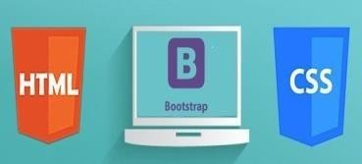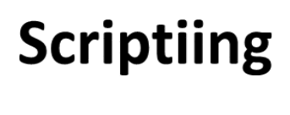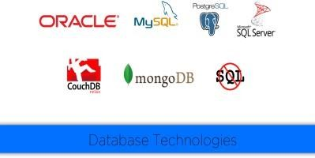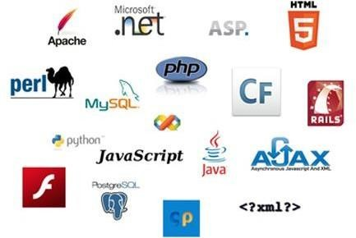

**Web Site**

**UI**

**Data Base**

### **3.1 UI DEVELOPMENT**

### Technologies that are mostly used to develop a User Interface are:

* HTML
* CSS
* Bootstrap

### **3.1.1 HTML**

**Hypertext Markup Language** (**HTML**) is the standard [markup language](https://en.wikipedia.org/wiki/Markup_language) for creating [web pages](https://en.wikipedia.org/wiki/Web_page) and [web applications](https://en.wikipedia.org/wiki/Web_application). With [Cascading Style Sheets](https://en.wikipedia.org/wiki/Cascading_Style_Sheets) (CSS) and [JavaScript](https://en.wikipedia.org/wiki/JavaScript) it forms a triad of cornerstone technologies for the [World Wide Web](https://en.wikipedia.org/wiki/World_Wide_Web). [Web browsers](https://en.wikipedia.org/wiki/Web_browser) receive HTML documents from a [web server](https://en.wikipedia.org/wiki/Webserver) or from local storage and render them into multimedia web pages. HTML describes the structure of a web page [semantically](https://en.wikipedia.org/wiki/Semantic) and originally included cues for the appearance of the document.

[HTML elements](https://en.wikipedia.org/wiki/HTML_element) are the building blocks of HTML pages. With HTML constructs, [images](https://en.wikipedia.org/wiki/Img_%28HTML_element%29) and other objects, such as [interactive forms,](https://en.wikipedia.org/wiki/Fieldset) may be embedded into the rendered page. It provides a means to create [structured documents](https://en.wikipedia.org/wiki/Structured_document) by denoting structural [semantics](https://en.wikipedia.org/wiki/Semantics) for text such as headings, paragraphs, lists, [links](https://en.wikipedia.org/wiki/Hyperlink), quotes and other items. HTML elements are delineated by tags, written using [angle brackets](https://en.wikipedia.org/wiki/Bracket#Angle_brackets). Tags such as <img /> and <input /> introduce content into the page directly. Others such as <p>...</p> surround and provide information about document text and may include other tags as sub-elements. Browsers do not display the HTML tags, but use them to interpret the content of the page.

HTML can embed programs written in a [scripting language](https://en.wikipedia.org/wiki/Scripting_language) such as [JavaScript](https://en.wikipedia.org/wiki/JavaScript) which affect the behavior and content of web pages. Inclusion of CSS defines the look and layout of content. The [World Wide Web Consortium](https://en.wikipedia.org/wiki/World_Wide_Web_Consortium) (W3C), maintainer of both the HTML and the CSS standards, has encouraged the use of CSS over explicit presentational HTML since 1997.

HTML markup consists of several key components, including those called tags (and their attributes), character-based data types, character references and entity references. HTML tags most commonly come in pairs like <h1> and </h1>, although some represent empty elements and so are unpaired, for example <img>. The first tag in such a pair is the start tag, and the second is the end tag (they are also called opening tags and closing tags).Another important component is the HTM[L document type declaration,](https://en.wikipedia.org/wiki/Document_type_declaration) which triggers [standards mode](https://en.wikipedia.org/wiki/Standards_mode) rendering.

The following is an example of the classic [Hello world program,](https://en.wikipedia.org/wiki/Hello_world_program) a common test employed for comparing [programming languages,](https://en.wikipedia.org/wiki/Programming_language) [scripting languages](https://en.wikipedia.org/wiki/Scripting_language) and [markup languages](https://en.wikipedia.org/wiki/Markup_language). This example is made using 9 [lines of code](https://en.wikipedia.org/wiki/Lines_of_code):

### **General Syntax of HTML**

<!DOCTYPE html>

<html>

<head>

<title>This is a title</title>

</head>

<body>

<p>Hello world! </p>

</body>

</html>

(The text between <html> and </html> describes the web page, and the text between <body> and </body> is the visible page content. The markup text "<title>This is a title</title>" defines the browser page title.)

The Document Type Declaration <!DOCTYPE html> is for HTML5. If a declaration is not included, various browsers will revert to "[quirks mode](https://en.wikipedia.org/wiki/Quirks_mode)" for rendering.

### **3.1.2 CSS**

**Cascading Style Sheets** (**CSS**) is a [style sheet language](https://en.wikipedia.org/wiki/Style_sheet_language) used for describing the [presentation](https://en.wikipedia.org/wiki/Presentation_semantics) of a document written in a [markup language.](https://en.wikipedia.org/wiki/Markup_language) Although most often used to set the visual style of [web pages](https://en.wikipedia.org/wiki/Web_page) and user interfaces written in [HTML](https://en.wikipedia.org/wiki/HTML) and [XHTML](https://en.wikipedia.org/wiki/XHTML), the language can be applied to any [XML](https://en.wikipedia.org/wiki/XML) document, including [plain XML](https://en.wikipedia.org/wiki/Plain_Old_XML), [SVG](https://en.wikipedia.org/wiki/Scalable_Vector_Graphics) and [XUL](https://en.wikipedia.org/wiki/XUL), and is applicable to rendering in [speech,](https://en.wikipedia.org/wiki/Speech_synthesis) or on other media. Along with HTML and [JavaScript](https://en.wikipedia.org/wiki/JavaScript), CSS is a cornerstone technology used by most websites to create visually engaging web pages, user interfaces for [web applications,](https://en.wikipedia.org/wiki/Web_applications) and user interfaces for many mobile applications.

CSS is designed primarily to enable the separation of presentation and content, including aspects such as the [layout](https://en.wikipedia.org/wiki/Page_layout), [colors](https://en.wikipedia.org/wiki/Color), and [fonts](https://en.wikipedia.org/wiki/Typeface). This separation can improve content [accessibility,](https://en.wikipedia.org/wiki/Accessibility) provide more flexibility and control in the specification of presentation characteristics, enable multiple HTML pages to share formatting by specifying the relevant CSS in a separate .css file, and reduce complexity and repetition in the structural content.

Separation of formatting and content makes it possible to present the same markup page in different styles for different rendering methods, such as on-screen, in print, by voice (via speech-based browser or [screen reader](https://en.wikipedia.org/wiki/Screen_reader)), and on [Braille-based](https://en.wikipedia.org/wiki/Braille_display) tactile devices. It can also display

the web page differently depending on the screen size or viewing device. Readers can also specify a different style sheet, such as a CSS file stored on their own computer, to override the one the author specified.

Changes to the [graphic design](https://en.wikipedia.org/wiki/Graphic_design) of a document (or hundreds of documents) can be applied quickly and easily, by editing a few lines in the CSS file they use, rather than by changing markup in the documents.

The CSS specification describes a priority scheme to determine which style rules apply if more than one rule matches against a particular element. In this so-called cascade, priorities (or weights) are calculated and assigned to rules, so that the results are predictable.

The CSS specifications are maintained by the [World Wide Web Consortium](https://en.wikipedia.org/wiki/World_Wide_Web_Consortium) (W3C). Internet media type ([MIME type](https://en.wikipedia.org/wiki/MIME_media_type)) text/CSS is registered for use with CSS by [RFC 2318](https://tools.ietf.org/html/rfc2318) (March 1998). The W3C operates a free [CSS validation service](https://en.wikipedia.org/wiki/W3C_Markup_Validation_Service#CSS_validation) for CSS documents.

#### **Types of CSS:**

* **Inline CSS**: In this CSS is applied in between the tags

E.g.: <tag style=” styling”>Hello World</tag>

* **Internal CSS:**

In this code is defined inside the style tag in the head section of the HTML page.

#### **General Syntax:**

<html>

<head>

<style>

<! -- CSS STYLING -- >

</style>

</head>

</html>

* **External CSS:**

In this the CSS code is written on another page and is linked to the HTML page. It is advantageous to use this type of styling as we can use the same file to style various HTML pages.

External CSS uses the extension .CSS and is applied using the following syntax:

<html>

<head>

<link relation=” stylesheet” type=”CSS” href=”URL to the page”>

</head>

</html>

All the CSS style types are important but can be used in different situations.

* Inline CSS is used when only small changes are to be done to the HTML tag and the changes are to be reflected only to that specific tag
* Internal CSS is used when the individual HTML pages have to be designed differently. This also slows the page load system if the internal styling is long.
* External CSS files are maintained to design multiple pages and use common styles over various pages. It is useful as it helps in managing the resources in an easy manner.

Both HTML and CSS are used to create a UI but CSS behaves like a makeup on the face of an actress which makes her look even more beautiful than she is in reality.

And here is the difference:

##### 

##### **Before using CSS in HTML page**:

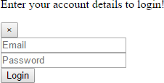

##### **After using CSS in HTML Page:**

**Fig 3.3**

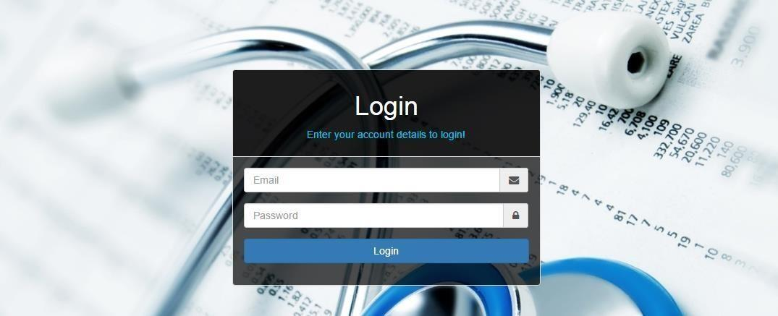

### 

### **3.1.3 BOOTSTRAP**

**Bootstrap** is a [free and open-source](https://en.wikipedia.org/wiki/Free_and_open-source_software) front-end [web framework](https://en.wikipedia.org/wiki/Web_framework) for designing [websites](https://en.wikipedia.org/wiki/Website) and [web applications.](https://en.wikipedia.org/wiki/Web_application) It contains [HTML](https://en.wikipedia.org/wiki/HTML)- and [CSS](https://en.wikipedia.org/wiki/CSS)-based design templates for [typography](https://en.wikipedia.org/wiki/Typography), forms, buttons, navigation and other interface components, as well as optional [JavaScript](https://en.wikipedia.org/wiki/JavaScript) extensions. Unlike many web frameworks, it concerns itself with [front-end development](https://en.wikipedia.org/wiki/Front-end_web_development) only.

Bootstrap is the second most-starred project on [GitHub](https://en.wikipedia.org/wiki/GitHub), with more than 107,000 stars and 48,000 forks.

Bootstrap, originally named Twitter Blueprint, was developed by Mark Otto and Jacob Thornton at [Twitter](https://en.wikipedia.org/wiki/Twitter) as a framework to encourage consistency across internal tools. Before Bootstrap, various libraries were used for interface development, which led to inconsistencies and a high maintenance burden. According to [twitter](https://en.wikipedia.org/wiki/Twitter) developer Mark Otto:

“A super small group of developers and I got together to design and build a new internal tool and saw an opportunity to do something more. Through that process, we saw ourselves build something much more substantial than another internal tool. Months later, we ended up with an early version of Bootstrap as a way to document and share common design patterns and assets within the company.”

After a few months of development by a small group, many developers at Twitter began to contribute to the project as a part of Hack Week, a [hackathon](https://en.wikipedia.org/wiki/Hackathon)-style week for the Twitter development team. It was renamed from Twitter Blueprint to Bootstrap, and released as an

open source project on August 19, 2011. It has continued to be maintained by Mark Otto, Jacob Thornton, and a small group of core developers, as well as a large community of contributors.

On January 31, 2012, Bootstrap 2 was released, which added a twelve-column [responsive](https://en.wikipedia.org/wiki/Responsive_web_design) grid layout system, inbuilt support for Glyph icons, several new components, as well as changes to many of the existing components.

On August 19, 2013, Bootstrap 3 was released, which redesigned components to use [flat](https://en.wikipedia.org/wiki/Flat_design)

design, and a [mobile first](https://en.wikipedia.org/wiki/Responsive_web_design#Mobile_first.2C_unobtrusive_JavaScript.2C_and_progressive_enhancement) approach.

On October 29, 2014, Mark Otto announced that Bootstrap 4 was in development. The first alpha version of Bootstrap 4 was released on August 19, 2015.

Bootstrap 3 supports the latest versions of Google [Chrome,](https://en.wikipedia.org/wiki/Google_Chrome) [Firefox](https://en.wikipedia.org/wiki/Firefox), [Internet](https://en.wikipedia.org/wiki/Internet_Explorer) [Explorer](https://en.wikipedia.org/wiki/Internet_Explorer), [Opera,](https://en.wikipedia.org/wiki/Opera_%28web_browser%29) and [Safari](https://en.wikipedia.org/wiki/Safari_%28web_browser%29) (except on Windows). It additionally supports back to [IE8](https://en.wikipedia.org/wiki/Internet_Explorer_8) and the latest [Firefox](https://en.wikipedia.org/wiki/Firefox) Extended Support Release (ESR).

Since 2.0, Bootstrap supports [responsive web design](https://en.wikipedia.org/wiki/Responsive_Web_Design). This means the layout of web pages adjusts dynamically, taking into account the characteristics of the device used (desktop, tablet, mobile phone).

Starting with version 3.0, Bootstrap adopted a [mobile-first design](https://en.wikipedia.org/wiki/Mobile-first_design) philosophy, emphasizing responsive design by default.

The version 4.0 alpha release added [Sass](https://en.wikipedia.org/wiki/Sass_%28stylesheet_language%29) and [flexbox](https://en.wikipedia.org/wiki/CSS_Flex_Box_Layout) support.

### **Installing and linking bootstrap to the HTML page:**

### Install bootstrap from <https://getbootstrap.com/>

* Copy the bootstrap.min.css file to your CSS folder and link it to the HTML page in the similar manner to how any other CSS file is linked.
* Link the bootstrap.min.js file which is present in the JS folder of the bootstrap. It can be linked using a script tag.

E.g.: <script src =”URL to bootstrap.min.js”></script>

* Now use bootstrap classes to reduce the work of designing which was earlier done through CSS.

### 

### **3.2 SCRIPTING**

There are two scripting methodologies.

1.Server-side scripting: This scripting is done at the server end

2.Client-side scripting: This scripting is done at the client end or the browser

### **3.2.1 SERVER-SIDE SCRIPTING**

**Server-side scripting** is a technique used in [web development](https://en.wikipedia.org/wiki/Web_development) which involves employing [scripts](https://en.wikipedia.org/wiki/Scripting_language) on a web server which produce a response customized for each user’s (client’s) request to the website. The alternative is for the web server itself to deliver a [static](https://en.wikipedia.org/wiki/Static_web_page) [web page.](https://en.wikipedia.org/wiki/Static_web_page) Scripts can be written in any of a number of server-side scripting languages that are available (see below). Server-side scripting is distinguished from [client-side scripting](https://en.wikipedia.org/wiki/Client-side_scripting) where embedded scripts, such as [JavaScript](https://en.wikipedia.org/wiki/JavaScript), are run client-side in a [web browser](https://en.wikipedia.org/wiki/Web_browser), but both techniques are often used together.

Server-side scripting is often used to provide a customized interface for the user. These scripts may assemble client characteristics for use in customizing the response based on those characteristics, the user’s requirements, access rights, etc. Server-side scripting also enables the website owner to hide the source code that generates the interface, whereas with client-side scripting, the user has access to all the code received by the client. A down-side to the use of server-side scripting is that the client needs to make further requests over the network to the server in order to show new information to the user via the web browser. These requests can slow down the experience for the user, place more load on the server, and prevent use of the application when the user is disconnected from the server.

When the server serves data in a commonly used manner, for example according to the [HTTP](https://en.wikipedia.org/wiki/Hypertext_Transfer_Protocol) or [FTP protocols](https://en.wikipedia.org/wiki/File_Transfer_Protocol), users may have their choice of a number of client programs (most modern web browsers can request and receive data using both of those protocols). In the case of more specialized applications, programmers may write their own server, client, and communications protocol that can only be used with one another.

Programs that run on a user’s local computer without ever sending or receiving data over a network are not considered clients, and so the operations of such programs would not be considered client-side operations.

**3.2.1.1 Server-Side scripting Languages**

There are several languages that can be used for server-side programming:

* + - PHP
    - ASP.NET (C# OR Visual Basic)
    - C++
    - Java and JSP
    - Python
    - Ruby on Rails and so on.

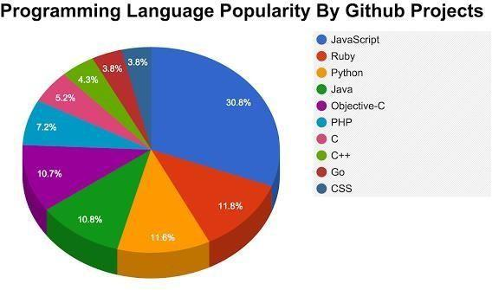

### **3.2.2 CLIENT-SIDE SCRIPTING**

Client-side scripting is changing interface behaviors within a specific web page in response to mouse or keyboard actions, or at specified timing events. In this case, the dynamic behavior occurs within the [presentation.](https://en.wikipedia.org/wiki/Look_and_feel) The client-side content is generated on the user's local computer system.

Such web pages use presentation technology called [rich interfaced pages.](https://en.wikipedia.org/wiki/Rich_Internet_application#Methods_and_techniques) Client-side scripting languages like [JavaScript](https://en.wikipedia.org/wiki/JavaScript) or [ActionScript](https://en.wikipedia.org/wiki/ActionScript), used for [Dynamic HTML](https://en.wikipedia.org/wiki/Dynamic_HTML) (DHTML) and [Flash](https://en.wikipedia.org/wiki/Adobe_Flash) technologies respectively, are frequently used to orchestrate media types (sound, animations, changing text, etc.) of the presentation. Client-side scripting also allows the use of [remote scripting,](https://en.wikipedia.org/wiki/Remote_scripting) a technique by which the DHTML page requests additional information from a server, using a [hidden frame,](https://en.wikipedia.org/wiki/HTML_element#Frames) [XML Http Requests](https://en.wikipedia.org/wiki/XMLHttpRequest), or a [Web service](https://en.wikipedia.org/wiki/Web_service).

The first widespread use of JavaScript was in 1997, when the language was standardized as [ECMAScript](https://en.wikipedia.org/wiki/ECMAScript) and implemented in [Netscape 3.](https://en.wikipedia.org/wiki/Netscape)

Example:

The client-side content is generated on the client's computer. The web browser retrieves a page from the server, then processes the code embedded in the page (typically written in [JavaScript](https://en.wikipedia.org/wiki/JavaScript)) and displays the retrieved page's content to the user.

The most popularly used client-side scripting languages is **JavaScript**. Flow of request from browser to server:

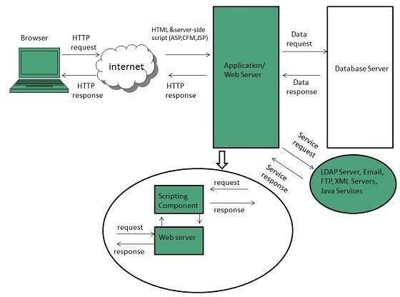

### 

### **3.3 DATABASE**

A **database** is an organized collection of [data.](https://en.wikipedia.org/wiki/Data_%28computing%29) It is the collection of [schemas, tables](https://en.wikipedia.org/wiki/Database_schema), [queries,](https://en.wikipedia.org/wiki/Query_language) reports, [views](https://en.wikipedia.org/wiki/View_%28SQL%29), and other objects. The data are typically organized to model aspects of reality in a way that supports [processes](https://en.wikipedia.org/wiki/Process_%28computing%29) requiring information, such as modelling the availability of rooms in hotels in a way that supports finding a hotel with vacancies.

A **database management system** (**DBMS**) is a [computer software](https://en.wikipedia.org/wiki/Computer_software) application that interacts with the user, other applications, and the database itself to capture and analyze data. A general-purpose DBMS is designed to allow the definition, creation, querying, update, and administration of databases. Well-known DBMSs include [MySQL, PostgreSQL,](https://en.wikipedia.org/wiki/MySQL) [MongoDB](https://en.wikipedia.org/wiki/MongoDB), [MariaDB,](https://en.wikipedia.org/wiki/MariaDB) [Microsoft SQL Server,](https://en.wikipedia.org/wiki/Microsoft_SQL_Server) [Oracle](https://en.wikipedia.org/wiki/Oracle_Database), [Sybase,](https://en.wikipedia.org/wiki/Sybase) [SAP HANA, MySQL](https://en.wikipedia.org/wiki/SAP_HANA) and [IBM DB2.](https://en.wikipedia.org/wiki/IBM_DB2) A database is not generally [portable](https://en.wikipedia.org/wiki/Software_portability) across different DBMSs, but different DBMS can interoperate by using [standards](https://en.wikipedia.org/wiki/Technical_standard) such as [SQL](https://en.wikipedia.org/wiki/SQL) and [ODBC](https://en.wikipedia.org/wiki/ODBC) or [JDBC](https://en.wikipedia.org/wiki/JDBC) to allow a single application to work with more than one DBMS. Database management systems are often classified according to the [database model](https://en.wikipedia.org/wiki/Database_model) that they support; the most popular database systems since the 1980s have all supported the [relational model](https://en.wikipedia.org/wiki/Relational_model) as represented by the [SQL](https://en.wikipedia.org/wiki/SQL) language. Sometimes a DBMS is loosely referred to as a "database".

### 

### **3.4 SQL**

Originally based upon [relational algebra](https://en.wikipedia.org/wiki/Relational_algebra) and [tuple relational calculus](https://en.wikipedia.org/wiki/Tuple_relational_calculus), SQL consists of a [data definition language](https://en.wikipedia.org/wiki/Data_definition_language), [data manipulation language](https://en.wikipedia.org/wiki/Data_manipulation_language), and [data control language](https://en.wikipedia.org/wiki/Data_control_language). The scope of SQL includes data insert, query, update and delete, [schema](https://en.wikipedia.org/wiki/Database_schema) creation and modification, and data access control. Although SQL is often described as, and to a great extent is, a [declarative](https://en.wikipedia.org/wiki/Declarative_programming) [language](https://en.wikipedia.org/wiki/Declarative_programming) ([4GL](https://en.wikipedia.org/wiki/4GL)), it also includes [procedural](https://en.wikipedia.org/wiki/Procedural_programming) elements.

SQL was one of the first commercial languages for Codd’s relational, as described in his influential 1970 paper, "A Relational Model of Data for Large Shared Data Banks." Despite not entirely adhering to [the relational model as described by Codd,](https://en.wikipedia.org/wiki/Codd%27s_12_rules) it became the most widely used database language.

SQL became a [standard](https://en.wikipedia.org/wiki/Technical_standard) of the [American National Standards Institute](https://en.wikipedia.org/wiki/American_National_Standards_Institute) (ANSI) in 1986, and of the [International Organization for Standardization](https://en.wikipedia.org/wiki/International_Organization_for_Standardization) (ISO) in 1987. Since then, the standard has been revised to include a larger set of features. Despite the existence of such standards, most SQL code is not completely portable among different database systems without adjustments.

### 

### **3.5 QUERIES**

The most common operation in SQL, the query, makes use of the declarative [SELECT](https://en.wikipedia.org/wiki/Select_%28SQL%29) statement. SELECT retrieves data from one or more [tables,](https://en.wikipedia.org/wiki/Table_%28database%29) or expressions. Standard SELECT statements have no persistent effects on the database. Some non-standard implementations of SELECT can have persistent effects, such as the SELECT INTO syntax provided in some databases.

Queries allow the user to describe desired data, leaving the [database management](https://en.wikipedia.org/wiki/Database_management_system) [system (DBMS)](https://en.wikipedia.org/wiki/Database_management_system) to carry out [planning,](https://en.wikipedia.org/wiki/Query_plan) [optimizing,](https://en.wikipedia.org/wiki/Query_optimizer) and performing the physical operations necessary to produce that result as it chooses.

A query includes a list of columns to include in the final result, normally immediately following the SELECT keyword. An asterisk ("*") can be used to specify that the query should return all columns of the queried tables. SELECT is the most complex statement in SQL, with optional keywords and clauses that include:

The [FROM](https://en.wikipedia.org/wiki/From_%28SQL%29) clause, which indicates the table(s) to retrieve data from. The FROM clause can include optional JOIN subclauses to specify the rules for joining tables.

The [WHERE](https://en.wikipedia.org/wiki/Where_%28SQL%29) clause includes a comparison predicate, which restricts the rows returned by the query. The WHERE clause eliminates all rows from the result set where the comparison predicate does not evaluate to True.

The GROUP BY clause projects rows having common values into a smaller set of rows. GROUP BY is often used in conjunction with SQL aggregation functions or to eliminate duplicate rows from a result set. The WHERE clause is applied before the GROUP BY clause.

The [HAVING](https://en.wikipedia.org/wiki/Having_%28SQL%29) clause includes a predicate used to filter rows resulting from the GROUP BY clause. Because it acts on the results of the GROUP BY clause, aggregation functions can be used in the HAVING clause predicate.

The [ORDER BY](https://en.wikipedia.org/wiki/Order_by_%28SQL%29) clause identifies which column[s] to use to sort the resulting data, and in which direction to sort them (ascending or descending). Without an ORDER BY clause, the order of rows returned by an SQL query is undefined.

The DISTINCT keyword eliminates duplicate data.

### **CHAPTER-4**

**SCRIPTING LANGUAGES**

* 1. PHP

|  |  |
| --- | --- |
| [**Paradigm**](https://en.wikipedia.org/wiki/Programming_paradigm) | [Imperative,](https://en.wikipedia.org/wiki/Imperative_programming) [functional,](https://en.wikipedia.org/wiki/Functional_programming) [object-oriented,](https://en.wikipedia.org/wiki/Object-oriented_programming) [procedural](https://en.wikipedia.org/wiki/Procedural_programming), [reflective](https://en.wikipedia.org/wiki/Reflective_programming) |
| [**Designed by**](https://en.wikipedia.org/wiki/Software_design) | [RasmusLerdorf](https://en.wikipedia.org/wiki/Rasmus_Lerdorf) |
| [**Developer**](https://en.wikipedia.org/wiki/Software_developer) | The PHP Development Team[, Zend Technologies](https://en.wikipedia.org/wiki/Zend_Technologies) |
| **First appeared** | June 8, 1995; 21 years ago[[1]](https://en.wikipedia.org/wiki/PHP#cite_note-mysqlconference-1) |
| [**Stable release**](https://en.wikipedia.org/wiki/Software_release_life_cycle) | 7.1.5 / May 11, 2017; 16 days ago, |
| [**Typing discipline**](https://en.wikipedia.org/wiki/Type_system) | [Dynamic](https://en.wikipedia.org/wiki/Dynamic_typing), [weak](https://en.wikipedia.org/wiki/Weak_typing), [gradual](https://en.wikipedia.org/wiki/Gradual_typing) (as of PHP 7.0.0) |
| **Implementation language** | [C](https://en.wikipedia.org/wiki/C_%28programming_language%29) (primarily; some components [C++](https://en.wikipedia.org/wiki/C%2B%2B)) |
| [**OS**](https://en.wikipedia.org/wiki/Operating_system) | [Unix-like](https://en.wikipedia.org/wiki/Unix-like), [Windows](https://en.wikipedia.org/wiki/Windows) |
| [**License**](https://en.wikipedia.org/wiki/Software_license) | [PHP License](https://en.wikipedia.org/wiki/PHP_License) (most of Zend Engine under [Zend Engine License](https://en.wikipedia.org/wiki/Zend_Engine_License)& The [TSRM License](https://en.wikipedia.org/w/index.php?title=TSRM_License&action=edit&redlink=1)) |
| [**Filename**](https://en.wikipedia.org/wiki/Filename_extension)[**extensions**](https://en.wikipedia.org/wiki/Filename_extension) | .php, .phtml, .php3, .php4, .php5, .php7,. phps |
| **Website** | [php.net](https://php.net/) |
| [**Major implementations**](https://en.wikipedia.org/wiki/Programming_language_implementation) | |
| [Zend Engine,](https://en.wikipedia.org/wiki/Zend_Engine) [HHVM,](https://en.wikipedia.org/wiki/HHVM) [Phalanger,](https://en.wikipedia.org/wiki/Phalanger_%28compiler%29) [Quercus,](https://en.wikipedia.org/wiki/Quercus_%28software%29) [Project Zero,](https://en.wikipedia.org/wiki/Project_Zero) [Parrot](https://en.wikipedia.org/wiki/Parrot_virtual_machine) | |
| **Influenced by** | |
| [C](https://en.wikipedia.org/wiki/C_%28programming_language%29), [C++,](https://en.wikipedia.org/wiki/C%2B%2B) [Java](https://en.wikipedia.org/wiki/Java_%28programming_language%29), [Perl](https://en.wikipedia.org/wiki/Perl), [Tcl[1]](https://en.wikipedia.org/wiki/Tcl) | |
| **Influenced** | |
| [Falcon,](https://en.wikipedia.org/wiki/Falcon_%28programming_language%29) [Hack](https://en.wikipedia.org/wiki/Hack_%28programming_language%29) | |

**PHP** is a [server-side scripting](https://en.wikipedia.org/wiki/Server-side_scripting) language designed primarily for [web development](https://en.wikipedia.org/wiki/Web_development) but also used as a [general-purpose programming language.](https://en.wikipedia.org/wiki/General-purpose_programming_language) Originally created by [RasmusLerdorf](https://en.wikipedia.org/wiki/Rasmus_Lerdorf) in 1994, the PHP [reference implementation](https://en.wikipedia.org/wiki/Reference_implementation) is now produced by ThePHP Development Team. PHP originally stood for *Personal Home Page*, but it now stands for the [recursive acronym](https://en.wikipedia.org/wiki/Recursive_acronym) *PHP: Hypertext Preprocessor*.

PHP code may be embedded into [HTML](https://en.wikipedia.org/wiki/HTML) or HTML5 [markup,](https://en.wikipedia.org/wiki/Markup_language) or it can be used in combination with various [web template systems](https://en.wikipedia.org/wiki/Web_template_system), [web content management systems](https://en.wikipedia.org/wiki/Web_content_management_system) and [web](https://en.wikipedia.org/wiki/Web_framework) [frameworks.](https://en.wikipedia.org/wiki/Web_framework) PHP code is usually processed by a PHP [interpreter](https://en.wikipedia.org/wiki/Interpreter_%28computing%29) implemented as a [module](https://en.wikipedia.org/wiki/Plugin_%28computing%29) in the web server or as a [Common Gateway Interface](https://en.wikipedia.org/wiki/Common_Gateway_Interface) (CGI) [executable](https://en.wikipedia.org/wiki/Executable). The [web server](https://en.wikipedia.org/wiki/Web_server) software combines the results of the interpreted and executed PHP code, which may be any type of data, including images, with the generated [web page.](https://en.wikipedia.org/wiki/Web_page) PHP code may also be executed with a [command-line interface](https://en.wikipedia.org/wiki/Command-line_interface) (CLI) and can be used to implement standalone graphical.

The standard PHP interpreter, powered by the [Zend Engine,](https://en.wikipedia.org/wiki/Zend_Engine) is [free software](https://en.wikipedia.org/wiki/Free_software) released under the [PHP License.](https://en.wikipedia.org/wiki/PHP_License) PHP has been widely ported and can be deployed on most web servers on almost every [operating system](https://en.wikipedia.org/wiki/Operating_system) and [platform,](https://en.wikipedia.org/wiki/Computing_platform) free of charge.

The PHP language evolved without a written [formal specification](https://en.wikipedia.org/wiki/Formal_specification) or standard until 2014, leaving the canonical PHP interpreter as a [*de facto*](https://en.wikipedia.org/wiki/De_facto) standard. Since 2014 work has gone on to create a formal PHP specification.

### Installing PHP

1. Step 1: download the files. Download the latest PHP 5 ZIP package from [www.php.net/downloads.php.](http://www.php.net/downloads.php) ...
2. Step 2: extract the files. ...
3. Step 3: configure php.ini. ...
4. Step 4: add C: php to the path environment variable. ...
5. Step 5: configure PHP as an Apache module. ...
6. Step 6: test a PHP file.
7. Or we can install **Xampp** which have inbuilt php, mysql,apache server We have used xampp to run the php fil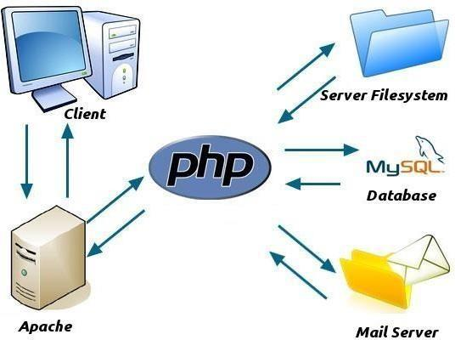es.

### **4.3 JAVA SCRIPT**

**JavaScript**, often abbreviated as "JS", is a [high-level](https://en.wikipedia.org/wiki/High-level_programming_language), [dynamic,](https://en.wikipedia.org/wiki/Dynamic_programming_language) [untyped](https://en.wikipedia.org/wiki/Untyped_language), and [interpreted](https://en.wikipedia.org/wiki/Interpreted_language) run-time [language.](https://en.wikipedia.org/wiki/Programming_language) It has been standardized in the [ECMAScript](https://en.wikipedia.org/wiki/ECMAScript) language specification. Alongside [HTML](https://en.wikipedia.org/wiki/HTML) and [CSS,](https://en.wikipedia.org/wiki/CSS) JavaScript is one of the three core technologies of [World Wide Web content production](https://en.wikipedia.org/wiki/World_Wide_Web); the majority of [websites](https://en.wikipedia.org/wiki/Website) employ it, and all modern [Web](https://en.wikipedia.org/wiki/Web_browser) [browsers](https://en.wikipedia.org/wiki/Web_browser) support it without the need for [plug-ins.](https://en.wikipedia.org/wiki/Browser_extension) JavaScript is [prototype-based](https://en.wikipedia.org/wiki/Prototype-based_programming) with [first-class](https://en.wikipedia.org/wiki/First-class_function) [functions,](https://en.wikipedia.org/wiki/First-class_function) making it a [multi-paradigm](https://en.wikipedia.org/wiki/Multi-paradigm) language, supporting [object-oriented](https://en.wikipedia.org/wiki/Object-oriented_programming), [imperative](https://en.wikipedia.org/wiki/Imperative_programming), and [functional programming styles.](https://en.wikipedia.org/wiki/Functional_programming) It has an [API](https://en.wikipedia.org/wiki/Application_programming_interface) for working with text, [arrays](https://en.wikipedia.org/wiki/Array_data_type), dates and [regular](https://en.wikipedia.org/wiki/Regular_expression) [expressions](https://en.wikipedia.org/wiki/Regular_expression), but does not include any [I/O,](https://en.wikipedia.org/wiki/Input/output) such as networking, storage, or graphics facilities, relying on these upon the host environment in which it is embedded.

Although there are strong outward similarities between JavaScript and Java, including language name, [syntax](https://en.wikipedia.org/wiki/Syntax_%28programming_languages%29), and respective [standard libraries,](https://en.wikipedia.org/wiki/Standard_library) the two are distinct languages and differ greatly in their design. JavaScript was influenced by programming languages such as [self](https://en.wikipedia.org/wiki/Self_%28programming_language%29) and [Scheme.](https://en.wikipedia.org/wiki/Scheme_%28programming_language%29)

JavaScript is also used in environments that are not Web-based, such as [PDF](https://en.wikipedia.org/wiki/Portable_Document_Format) documents, [site-specific browsers,](https://en.wikipedia.org/wiki/Site-specific_browser) and [desktop widgets.](https://en.wikipedia.org/wiki/Desktop_widget) Newer and faster JavaScript [virtual](https://en.wikipedia.org/wiki/Virtual_machine) [machines](https://en.wikipedia.org/wiki/Virtual_machine) (VMs) and platforms built upon them have also increased the popularity of JavaScript for [server-side Web applications](https://en.wikipedia.org/wiki/Server-side). On the [client side](https://en.wikipedia.org/wiki/Client_side), developers have traditionally implemented JavaScript as an [interpreted](https://en.wikipedia.org/wiki/Interpreter_%28computing%29) language, but more recent browsers perform [just-in-time](https://en.wikipedia.org/wiki/Just-in-time_compilation) [compilation](https://en.wikipedia.org/wiki/Just-in-time_compilation). Programmers also use JavaScript in [video-game development](https://en.wikipedia.org/wiki/Video_game_development), in crafting desktop and mobile applications, and in server-side [network programming](https://en.wikipedia.org/wiki/Computer_network_programming) with [run-time environments](https://en.wikipedia.org/wiki/Runtime_system) such as [Node.js.](https://en.wikipedia.org/wiki/Node.js)

### **4.4 JQUERY**

**jQuery** is a [cross-platform](https://en.wikipedia.org/wiki/Cross-platform) [JavaScript library](https://en.wikipedia.org/wiki/JavaScript_library) designed to simplify the [client-side](https://en.wikipedia.org/wiki/Client-side_scripting) [scripting](https://en.wikipedia.org/wiki/Client-side_scripting) of [HTML.](https://en.wikipedia.org/wiki/HTML) It is [free, open-source software](https://en.wikipedia.org/wiki/Free_and_open_source_software) using the permissive [MIT license](https://en.wikipedia.org/wiki/MIT_license). [Web](https://en.wikipedia.org/wiki/World_Wide_Web) analysis indicates that it is the most widely deployed JavaScript library by a large margin.

jQuery’s syntax is designed to make it easier to navigate a document, select [DOM](https://en.wikipedia.org/wiki/Document_Object_Model) elements, create [animations](https://en.wikipedia.org/wiki/Animation), handle [events,](https://en.wikipedia.org/wiki/Event_%28computing%29) and develop [Ajax](https://en.wikipedia.org/wiki/Ajax_%28programming%29) applications. jQuery also provides capabilities for developers to create [plug-ins](https://en.wikipedia.org/wiki/Plug-in_%28computing%29) on top of the JavaScript library. This enables developers to create [abstractions](https://en.wikipedia.org/wiki/Abstraction_%28computer_science%29) for low-level interaction and animation, advanced effects and high-level, theme able widgets. The modular approach to the jQuery library allows the creation of powerful [dynamic web pages](https://en.wikipedia.org/wiki/Dynamic_web_page) and Web applictions.

The set of [jQuery core features](https://en.wikipedia.org/wiki/JQuery#Features)—DOM element selections, traversal and manipulation—enabled by its selector engine (named "Sizzle" from v1.3), created a new "programming style", fusing algorithms and DOM data structures. This style influenced the architecture of other [JavaScript frameworks](https://en.wikipedia.org/wiki/Comparison_of_JavaScript_frameworks) like [YUI v3](https://en.wikipedia.org/wiki/YUI_Library) and [Dojo](https://en.wikipedia.org/wiki/Dojo_Toolkit), later stimulating the creation of the standard Selectors API.

[Microsoft](https://en.wikipedia.org/wiki/Microsoft) and [Nokia](https://en.wikipedia.org/wiki/Nokia) bundle jQuery on their platforms. Microsoft includes it with [Visual Studio](https://en.wikipedia.org/wiki/Microsoft_Visual_Studio) for use within Microsoft's [ASP.NET AJAX](https://en.wikipedia.org/wiki/ASP.NET_AJAX) and [ASP.NET MVC](https://en.wikipedia.org/wiki/ASP.NET_MVC) frameworks while Nokia has integrated it into the Web Run-Time widget development PLATFORM

**4.5 AJAX**

**Ajax** (also **AJAX** short for "asynchronous [JavaScript](https://en.wikipedia.org/wiki/JavaScript) and [XML](https://en.wikipedia.org/wiki/XML)") is a set of [Web](https://en.wikipedia.org/wiki/Web_development) [development](https://en.wikipedia.org/wiki/Web_development) techniques using many Web technologies on the [client side](https://en.wikipedia.org/wiki/Client_side) to create [asynchronous Web applications](https://en.wikipedia.org/wiki/Asynchronous_I/O). With Ajax, Web applications can send data to and retrieve from a [server](https://en.wikipedia.org/wiki/Web_server) asynchronously (in the background) without interfering with the display and behavior of the existing page. By decoupling the data interchange layer from the presentation layer, Ajax allows for Web pages, and by extension Web applications, to change content dynamically without the need to reload the entire page. In practice, modern implementations commonly substitute [JSON](https://en.wikipedia.org/wiki/JSON) for XML due to the advantages of being native to JavaScript.

Ajax is not a single technology, but rather a group of technologies. [HTML](https://en.wikipedia.org/wiki/Hypertext_Markup_Language) and [CSS](https://en.wikipedia.org/wiki/Cascading_Style_Sheets) can be used in combination to mark up and style information. The [DOM](https://en.wikipedia.org/wiki/Document_Object_Model) is accessed with JavaScript to dynamically display – and allow the user to interact with – the information presented. JavaScript and the [XML HTTP Request](https://en.wikipedia.org/wiki/XMLHttpRequest) object provide a method for exchanging data asynchronously between browser and server to avoid full page reloads.

### **4.6 JSON**

[In computing,](https://en.wikipedia.org/wiki/Computing) **JavaScript Object Notation** or **JSON**  is an [open-](https://en.wikipedia.org/wiki/Open_standard) [standard file format](https://en.wikipedia.org/wiki/Open_standard) that uses [human-readable](https://en.wikipedia.org/wiki/Human-readable_medium) text to transmit data objects consisting of [attribute–value pairs](https://en.wikipedia.org/wiki/Attribute%E2%80%93value_pair) and [array data types](https://en.wikipedia.org/wiki/Array_data_type) (or any other [serializable](https://en.wikipedia.org/wiki/Serialization) value). It is a very common data format used for [asynchronous](https://en.wikipedia.org/wiki/Asynchronous_I/O) browser/server communication, including as a replacement for [XML](https://en.wikipedia.org/wiki/XML) in some [AJAX](https://en.wikipedia.org/wiki/Ajax_%28programming%29)-style systems.

JSON is [a language-independent](https://en.wikipedia.org/wiki/Language-independent_specification) data format. It was derived from [JavaScript](https://en.wikipedia.org/wiki/JavaScript), but as of 2017 many [programming languages](https://en.wikipedia.org/wiki/Programming_language) include code to generate and [parse](https://en.wikipedia.org/wiki/Parsing) JSON-format data. The official Internet [media type](https://en.wikipedia.org/wiki/Media_type) for JSON is application/json. JSON file names use the extension

. json.

[Douglas Crockford](https://en.wikipedia.org/wiki/Douglas_Crockford) originally specified the JSON format in the early 2000s; two competing standards, [RFC 7159](https://tools.ietf.org/html/rfc7159) and [ECMA-404](https://www.ecma-international.org/publications/standards/Ecma-404.htm), defined it in 2013. The ECMA standard describes only the allowed syntax, whereas the RFC covers some security and interoperability considerations.[[3]](https://en.wikipedia.org/wiki/JSON#cite_note-3)

A restricted profile of JSON, known as **I-JSON** (short for "Internet JSON"), seeks to overcome some of the interoperability problems with JSON. It is defined in [RFC 7493](https://tools.ietf.org/html/rfc7493).

### **4.7 XAMPP**



**Xampp** is a [free and open source cross platform](https://en.wikipedia.org/wiki/Free_software) [web server solution stack](https://en.wikipedia.org/wiki/Web_server) package developed by Apache Friends, consisting mainly of the [Apache HTTP Server](https://en.wikipedia.org/wiki/Apache_HTTP_Server), [MariaDB](https://en.wikipedia.org/wiki/MariaDB) [database](https://en.wikipedia.org/wiki/Database), and [interpreters](https://en.wikipedia.org/wiki/Interpreter_%28computing%29) for scripts written in the [PHP](https://en.wikipedia.org/wiki/PHP) and [Perl programming languages](https://en.wikipedia.org/wiki/Perl). XAMPP stands for Cross-Platform (X), Apache (A), MariaDB (M), PHP (P) and Perl (P). It is a simple, lightweight Apache distribution that makes it extremely easy for developers to create a local web server for testing and deployment purposes. Everything needed to set up a web server – server application (Apache), database (MariaDB), and scripting language (PHP) – is included in an extractable file. XAMPP is also cross-platform, which means it works equally well on Linux, Mac and Windows. Since most actual web server deployments use the same components as XAMPP, it makes transitioning from a local test server to a live server extremely easy as well.

### **4.8 FEATURES**

XAMPP is regularly updated to the latest releases of [Apache](https://en.wikipedia.org/wiki/Apache_HTTP_Server), [MariaDB](https://en.wikipedia.org/wiki/MariaDB), [PHP](https://en.wikipedia.org/wiki/PHP) and [Perl](https://en.wikipedia.org/wiki/Perl). It also comes with a number of other modules including [OpenSSL](https://en.wikipedia.org/wiki/OpenSSL), [phpMyAdmin](https://en.wikipedia.org/wiki/PhpMyAdmin), [Media Wiki](https://en.wikipedia.org/wiki/MediaWiki), [Joomla](https://en.wikipedia.org/wiki/Joomla), [WordPress](https://en.wikipedia.org/wiki/WordPress) and more. Self-contained, multiple instances of XAMPP can exist on a single computer, and any given instance can be copied from one computer to another. XAMPP is offered in both a full and a standard version (Smaller version).

**4.9 USAGE**

Officially, XAMPP's designers intended it for use only as a development tool, to allow website designers and programmers to test their work on their own computers without any access to the Internet. To make this as easy as possible, many important security features are disabled by default. XAMPP has the ability to serve web pages on the [World Wide Web.](https://en.wikipedia.org/wiki/World_Wide_Web) A special tool is provided to [password-protect](https://en.wikipedia.org/wiki/Password) the most important parts of the package.

XAMPP also provides support for creating and manipulating databases in [MariaDB](https://en.wikipedia.org/wiki/MariaDB) and [SQLite](https://en.wikipedia.org/wiki/SQLite) among others. Once XAMPP is installed, it is possible to treat a [localhost](https://en.wikipedia.org/wiki/Localhost) like a remote host by connecting using an [FTP](https://en.wikipedia.org/wiki/File_Transfer_Protocol) client. Using a program like [FileZilla](https://en.wikipedia.org/wiki/FileZilla) has many advantages when installing a [content management system](https://en.wikipedia.org/wiki/Content_management_system) (CMS) like [Joomla](https://en.wikipedia.org/wiki/Joomla) or [WordPress](https://en.wikipedia.org/wiki/WordPress). It is also possible to connect to localhost via FTP with an [HTML editor](https://en.wikipedia.org/wiki/HTML_editor).

**CHAPTER-5**

### **SOFTWARE REQUIREMENT SPECIFICATION**

**5.1 Hardware Requirements**

The selection of hardware is very important in the existence and proper working of any software. When selecting hardware, the size and requirements are also important.

|  |  |
| --- | --- |
| Processor | Intel CORE i5 |
| RAM | **4.0 GB** |
| Hard Disk Drive | **500 GB** |

**5.2 Software Requirements**

|  |  |
| --- | --- |
| **Number** | **Description** |
| 1 | Windows 10 |
| 2 | HTML/CSS/Ajax/JavaScript/  Bootstrap. |
| 3 | Apache server/ XAMP SERVER |
| 4 | PHP 5.5.38 |
| 4 | MySQL |
| 5 | Compiler: MSVC11 (Visual C++ 2012) |
| 6 | Apache version: Apache/2.4.23 (Win32) OpenSSL/1.0.2h PHP/5.5.38 |

**ENTITY-RELATIONSHIP Diagram:**

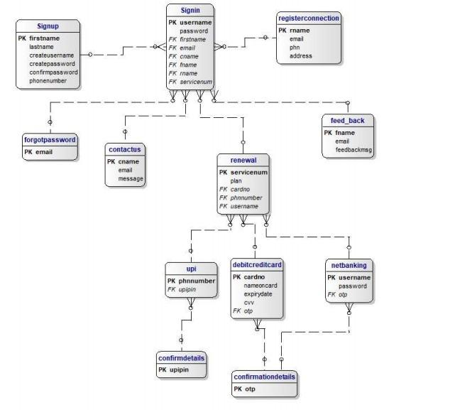

**CHAPTER-7**

### **PROJECT**

**Name:** ONLINE BROADBAND CONNECTION SERVICES

##### **7.1 Technologies Used:**

* + - HTML
    - CSS
    - Bootstrap
    - SQL
    - Java Script
    - JSON
    - jQuery
    - Node.JS
    - AJAX

**Server:** Local Host

**Database:** MySQL

**Operating System:** Windows7/8/8.1/10

**Wireframing tool:** Paint

##### **Team Size:** 4

**7.2 TECHNICAL DETAILS**

* + - Front end is designed using HTML, CSS and Bootstrap. Ajax used to perform behind the screen requests and JavaScript used to perform client-side scripting
    - Backend is based on MySQL based RDB (Relational Database) model.
    - The SQL queries are run using the CI SQL library functions
    - Backend online host includes a centralized database resident on the server, the script which is built in PHP used to SQL query the database on user’s request for transaction of data
    - The forms are made using the HTML, Bootstrap for designing and SQL for back-end
    - JavaScript, AJAX and jQuery used for client-side scripting and PHP for the server-side development

### 

### **CHAPTER-8**

### **SCREENSHOTS**

1. **Configuration database(config.db.js)**

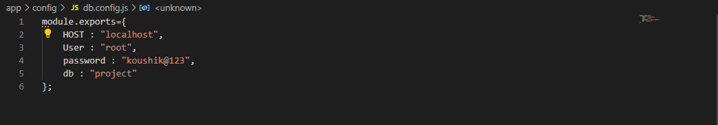

**Connection of MY SQL DATABASE**

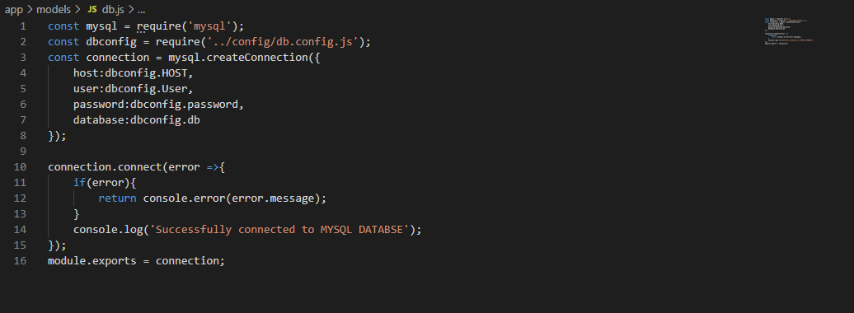

**Creating Database in the MYSQL Workbench**



## 

## **API Code, Validations & Outputs of Data in the Database**

**1.Signin API Code-Model.js**

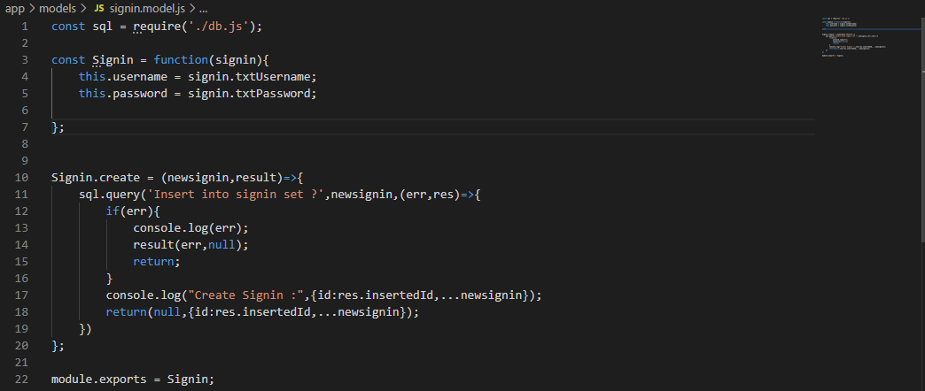

**Controller.js**

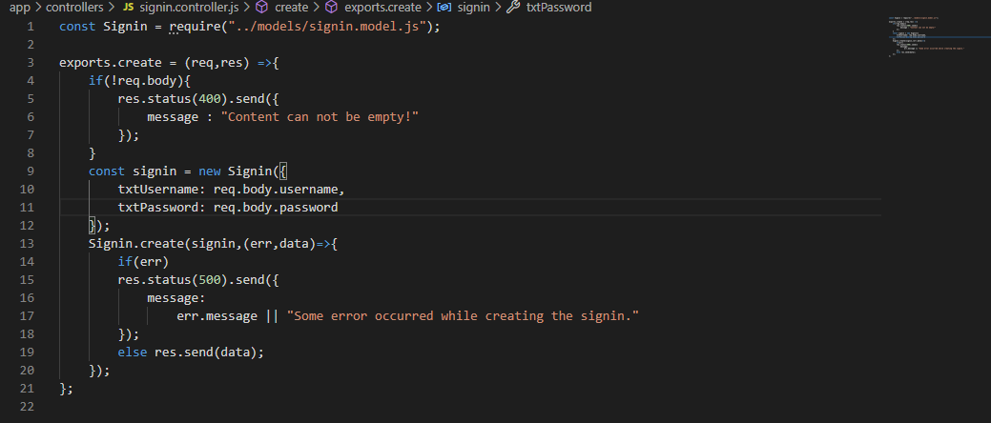

**Routes.js**

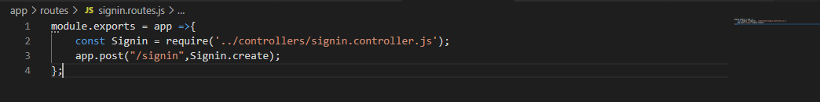

**server.js**

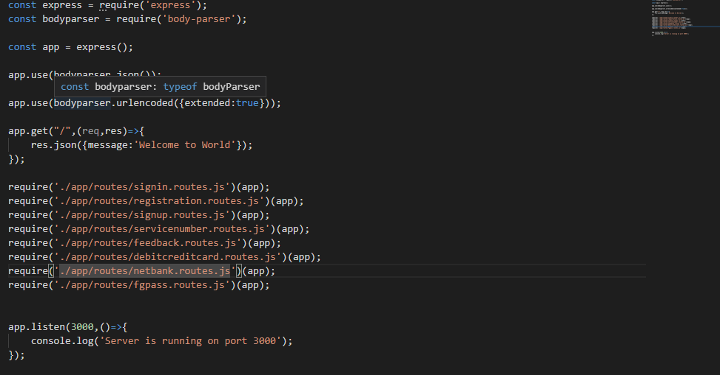

**Validations and Ajax for signin**

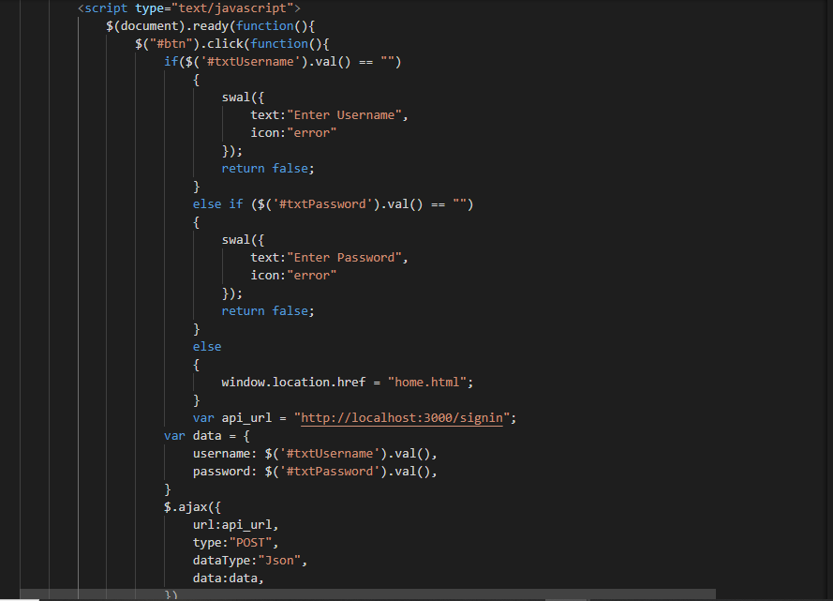

**Creating the table of signin**



**Output of data in Database**

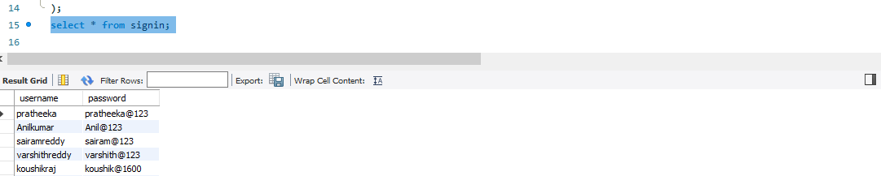

**2.Signup API Code-model.js**

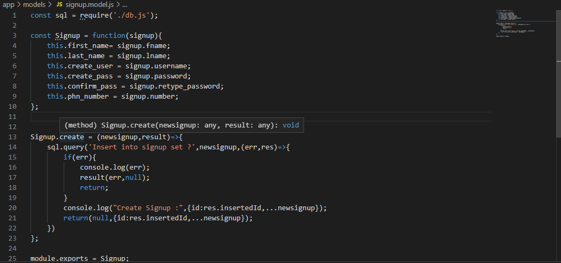

**Controller.js**

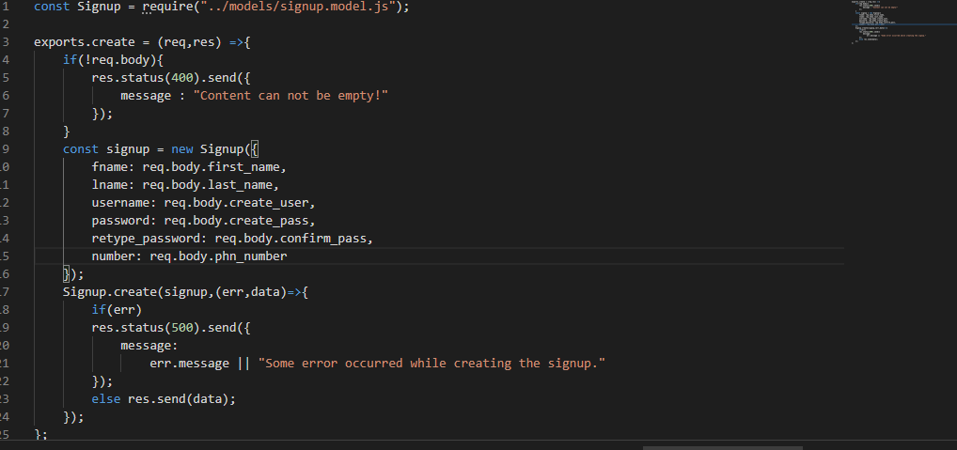

**routes.js**

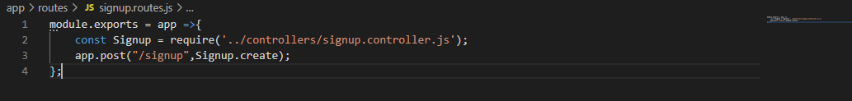

**server.js**

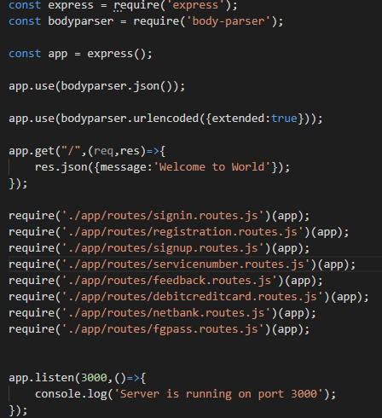

**Signup Validations**

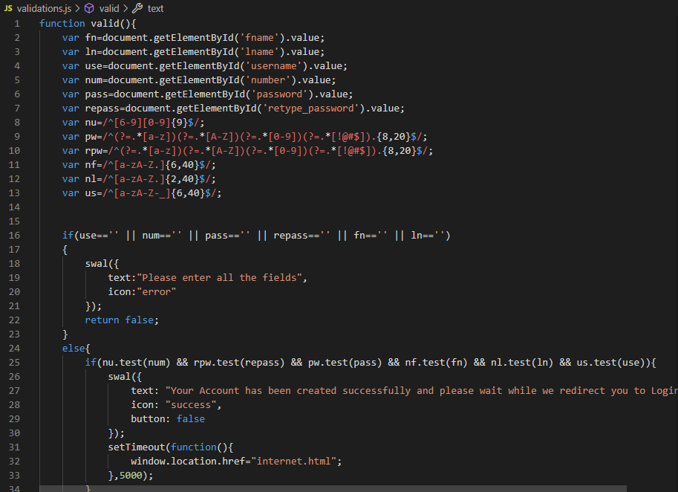

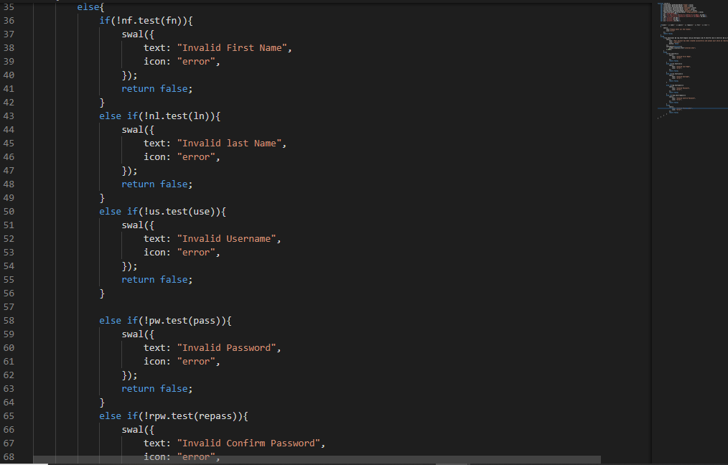

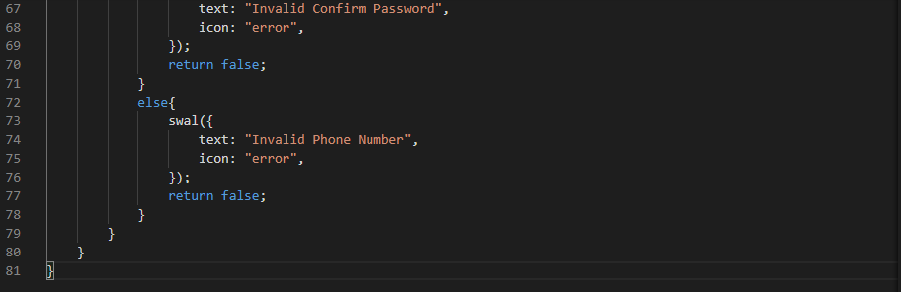

**Signup Ajax**

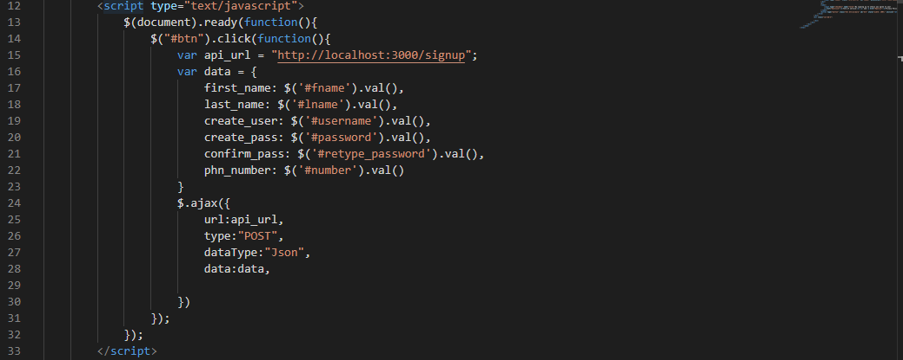

**Creating table of signup**

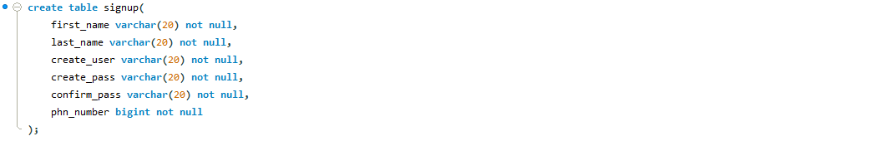

**Output of data in Database**

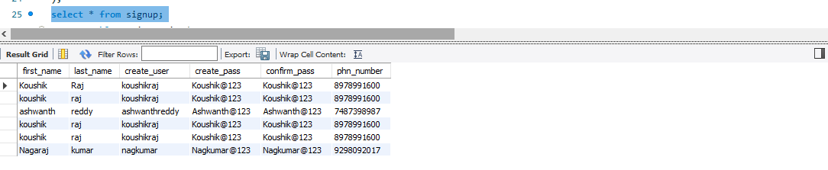

**3.Forgot password API-model.js**

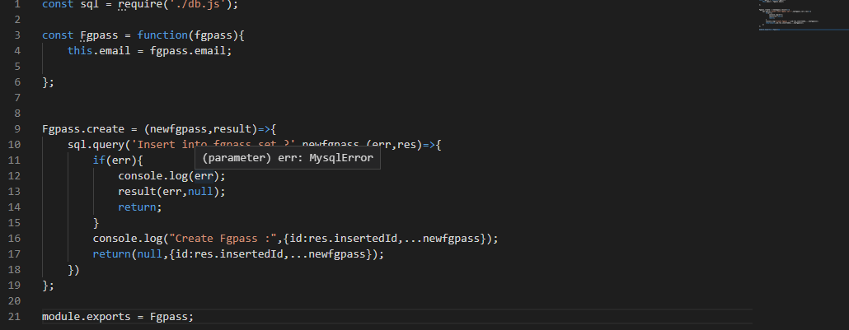

**Controller.js**

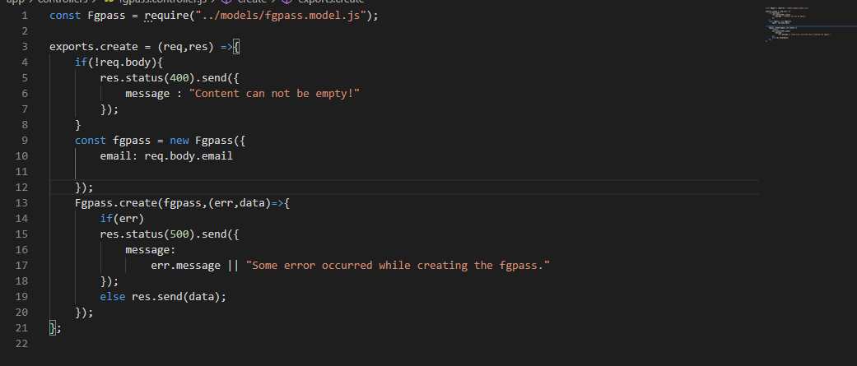

**routes.js**



**server.js**



**Validations and Ajax**

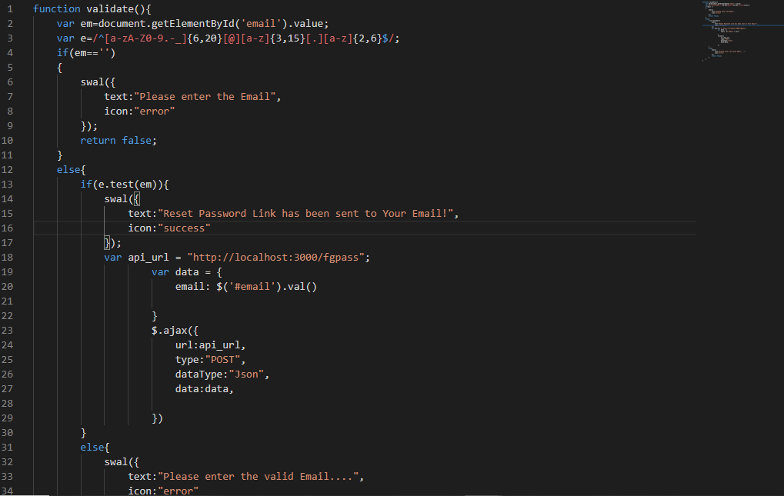

**Creating table of forgot password**



**Output of data in Database**

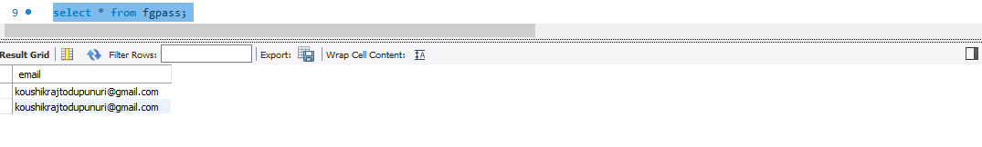

**4.Renewal API Code-model.js**

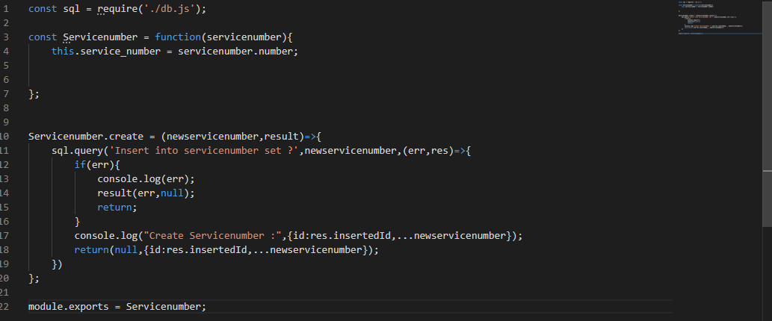

**Controller.js**

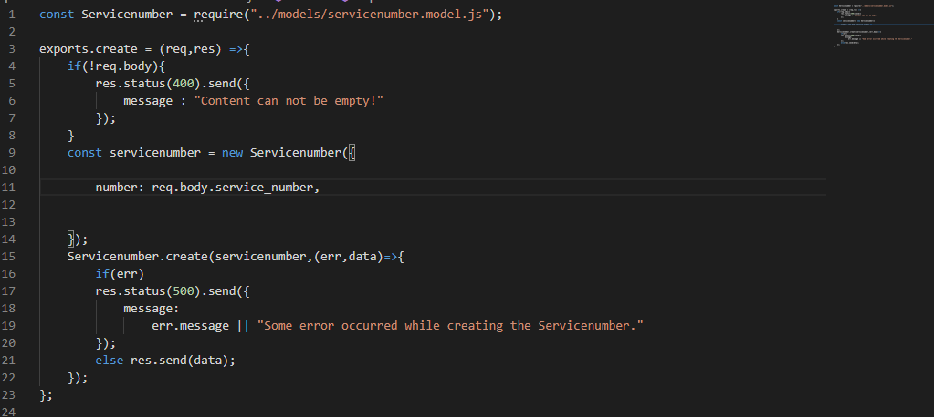

**routes.js**



**server.js**

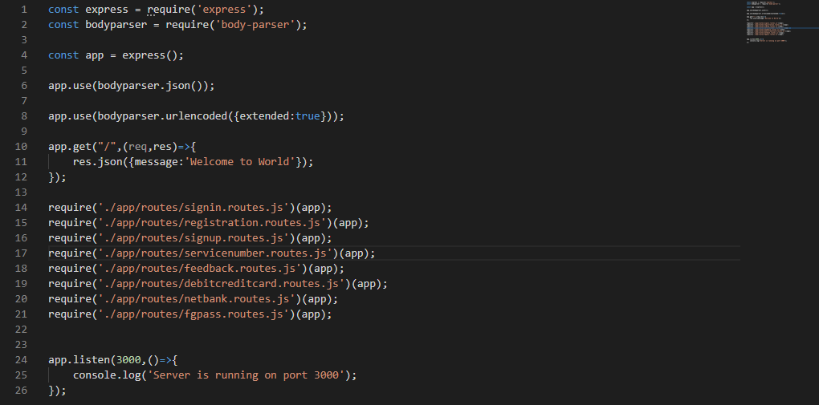

**Validations and Ajax**

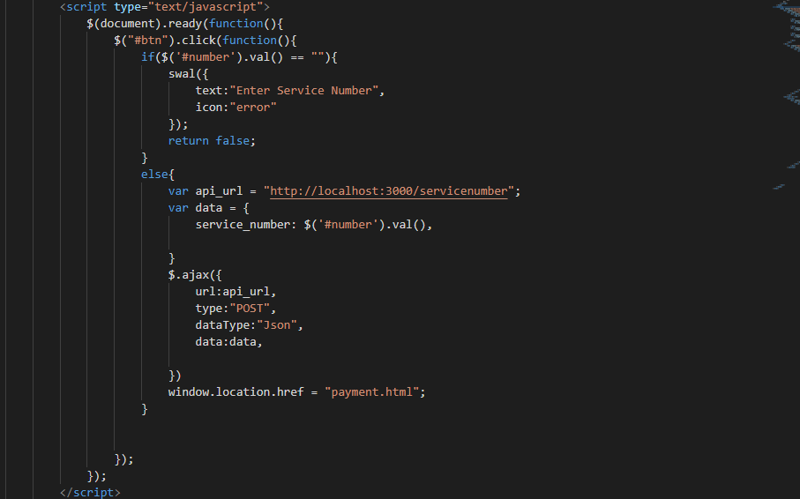

**Creating table for renewal**



**Output of data in Database**

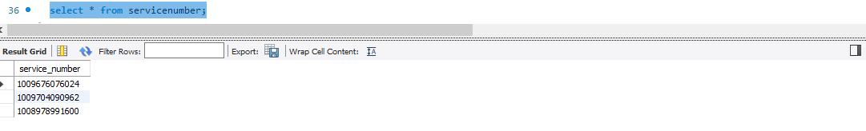

**5.API for Registration(model.js)**

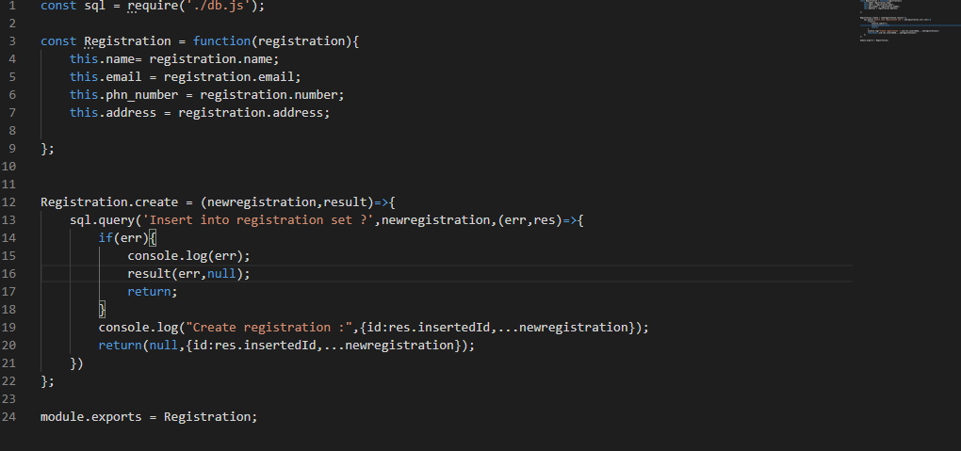

**controller.js**

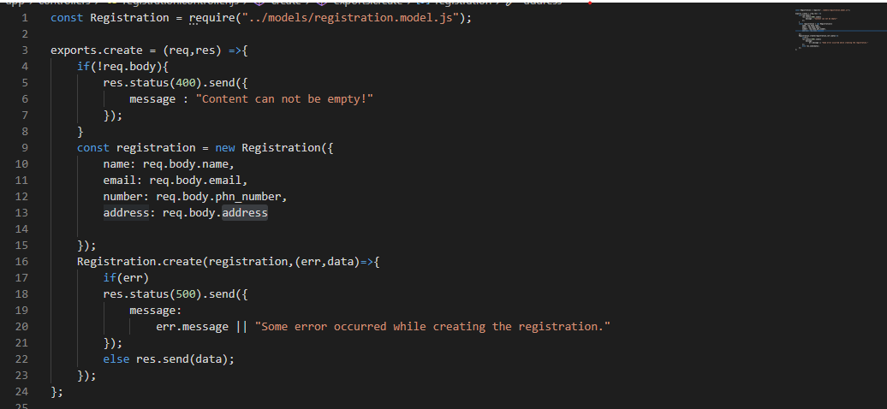

**routes.js**



**server.js**

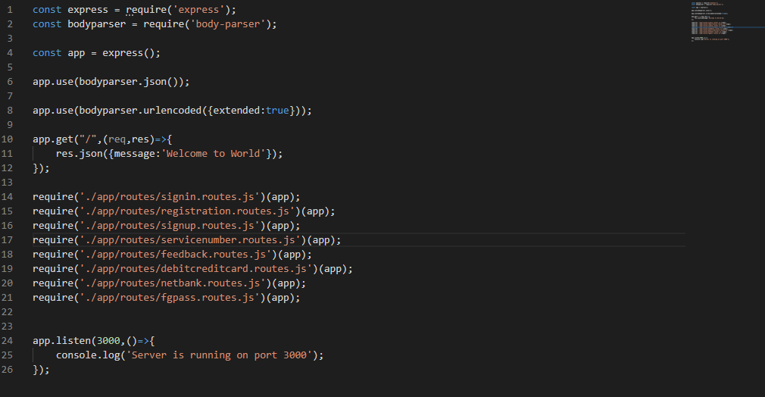

**Validations and Ajax**

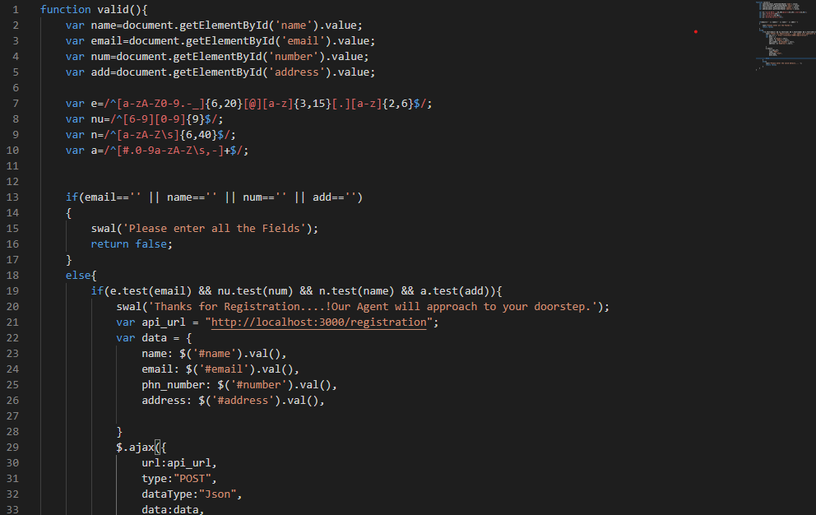

**Creating table for registration**

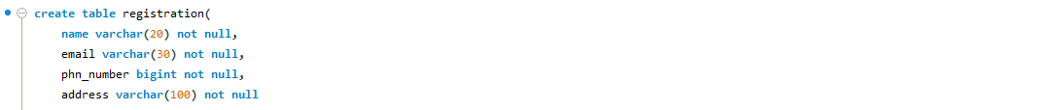

**Output of data in Database**

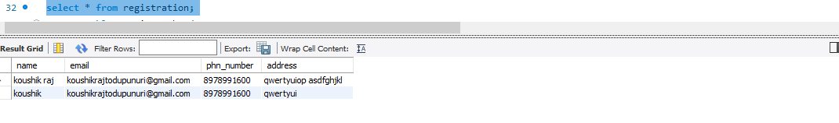

**6.API for Feedback(model.js)**

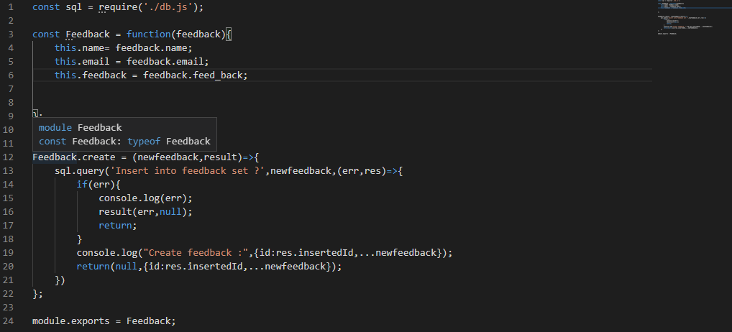

**controller.js**

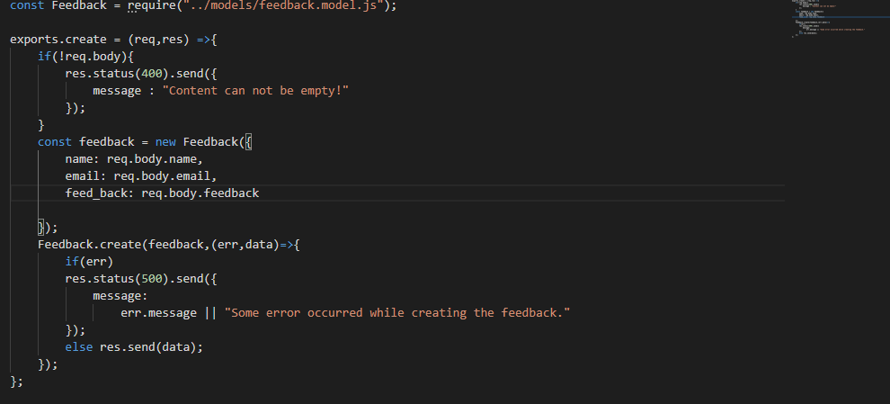

**routes.js**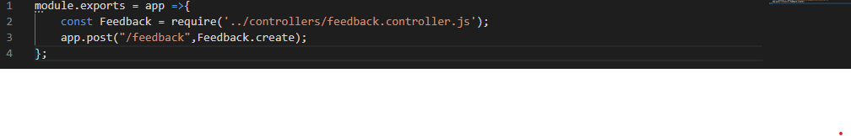

**server.js**

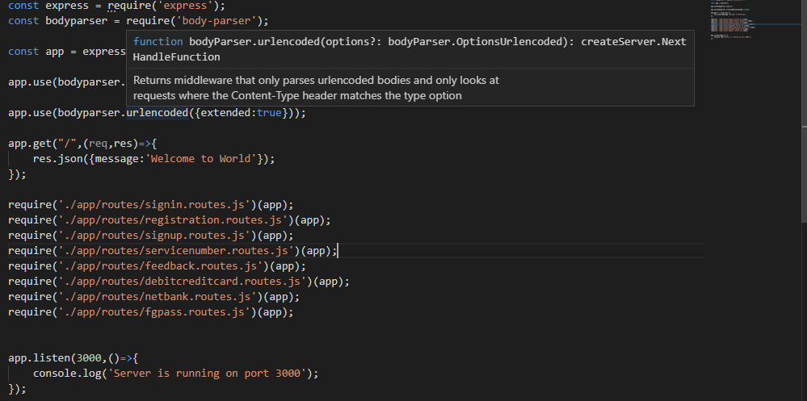

**Validation and Ajax**

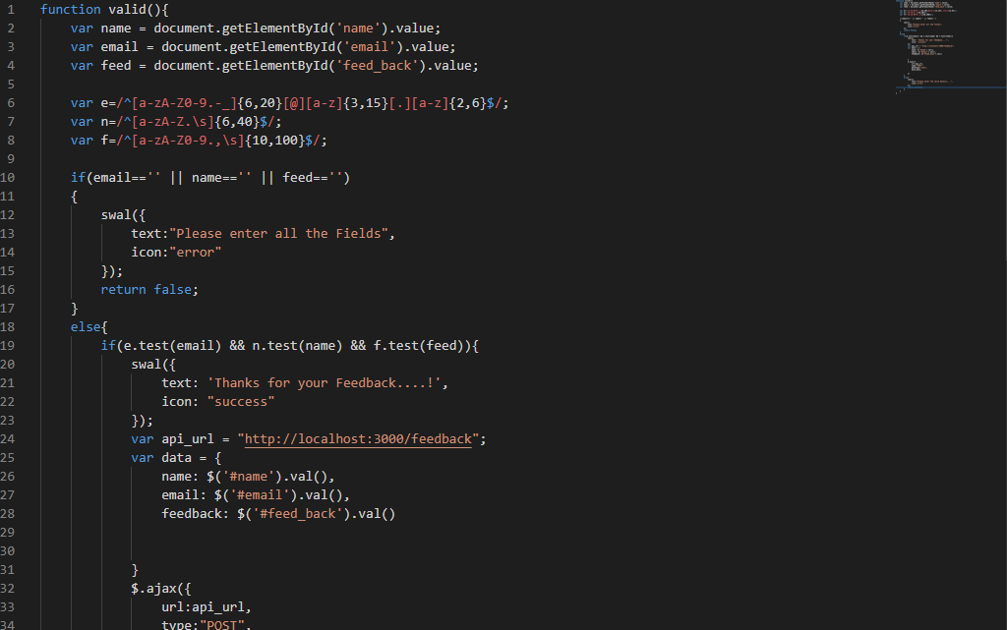

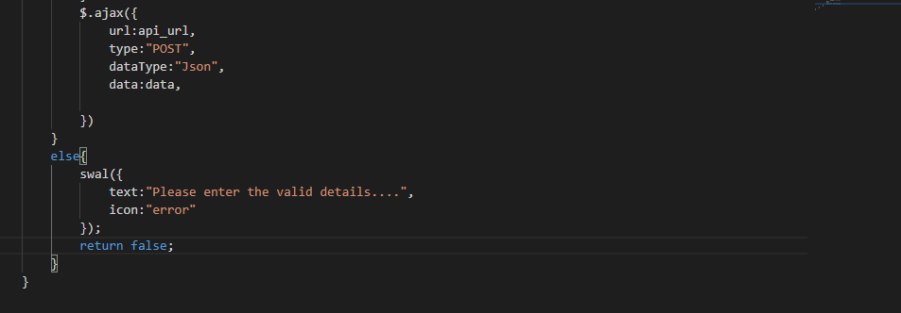

**Creating table for feedback**



**Output of data Database**

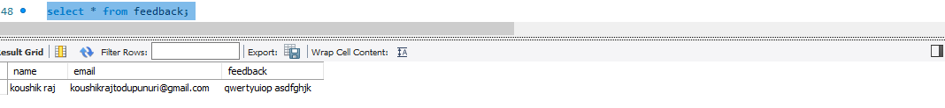

1. **API for Debit/credit card(model.js)**

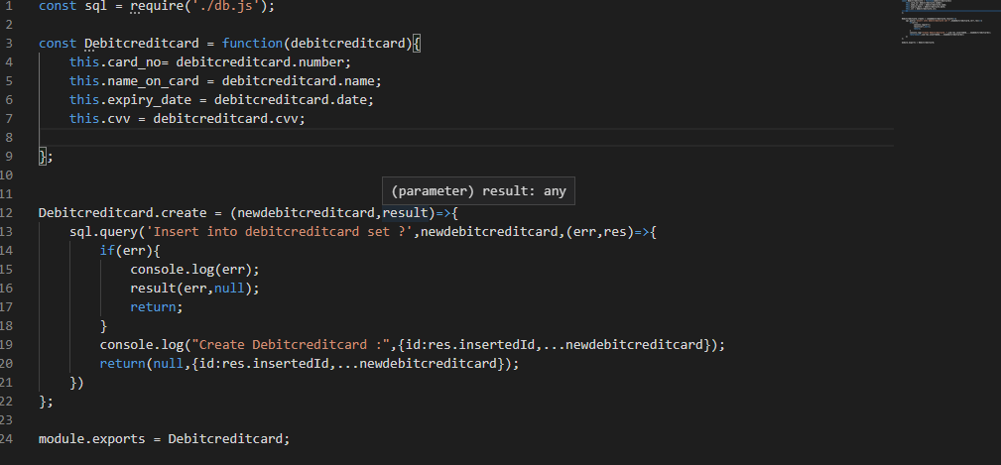

**controller.js**

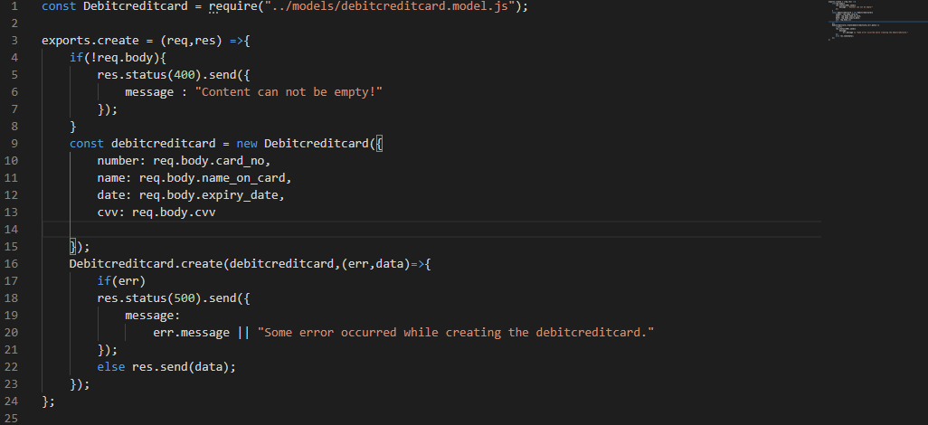

**routes.js**

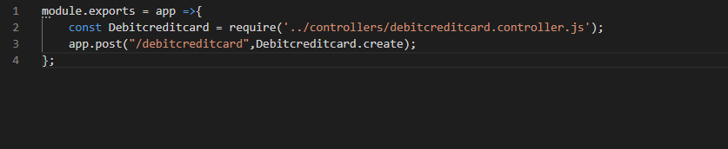

**server.js**

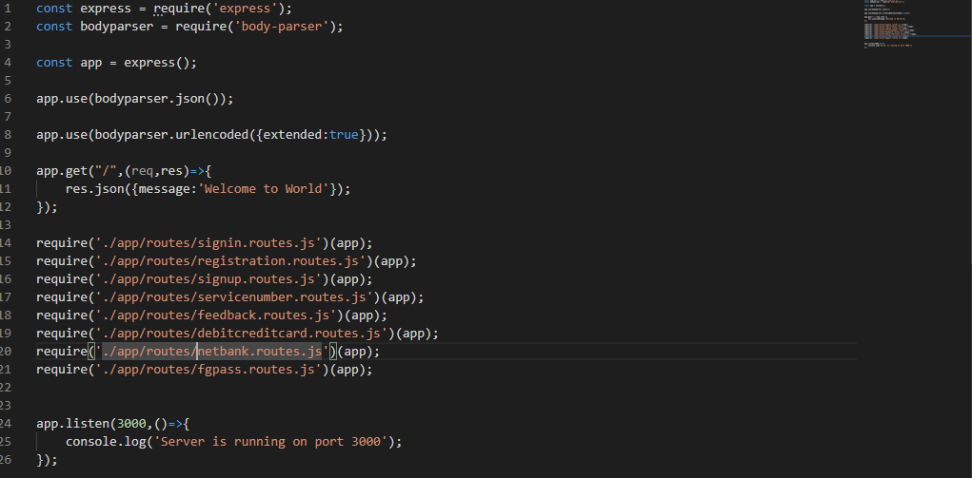

**Validations and Ajax**

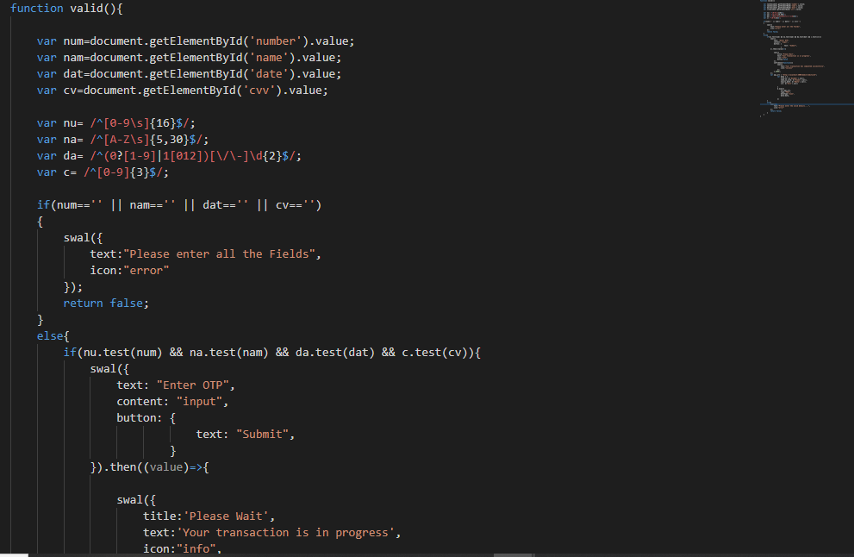

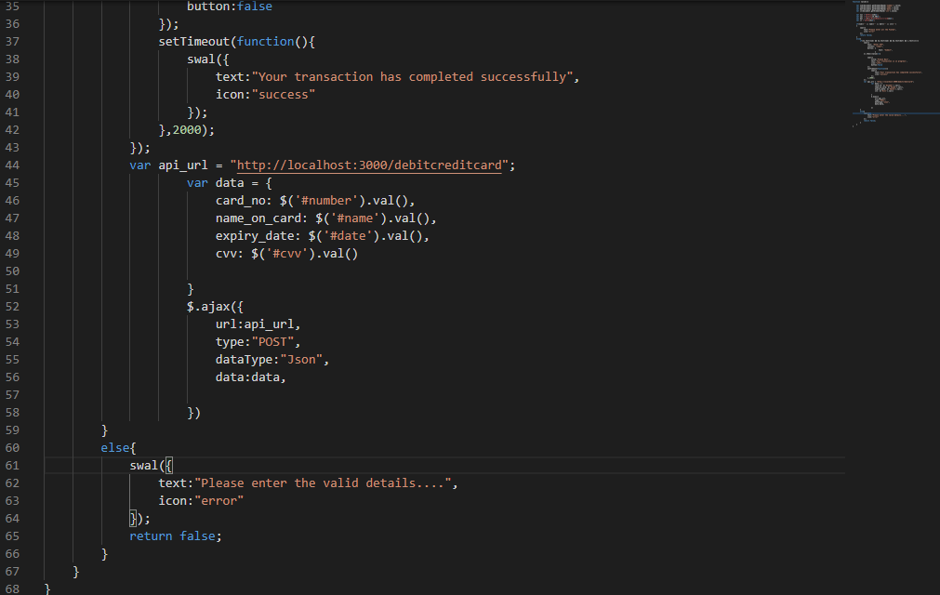

**Creating table for debit/credit card**

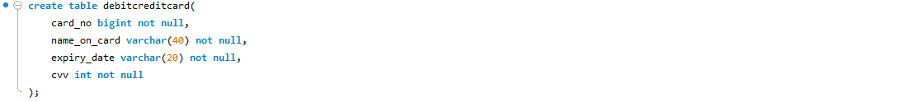

**Output of data Database**

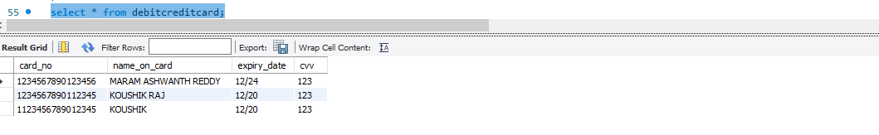

**8.API for Net banking (model.js)**

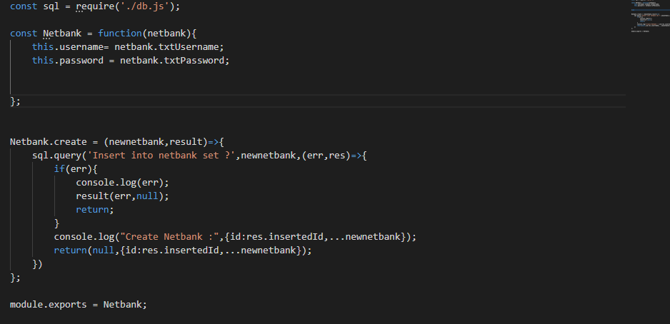

**controller.js**

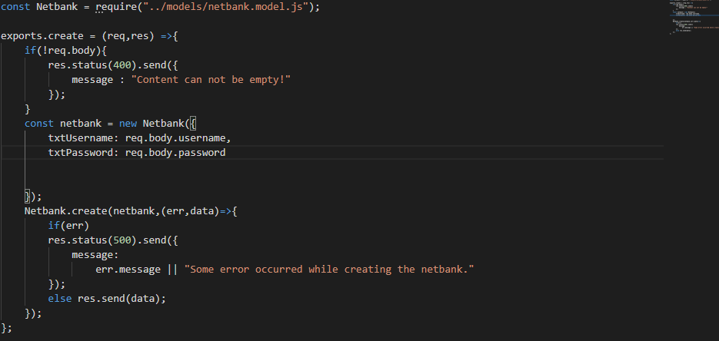

**routes.js**



**server.js**

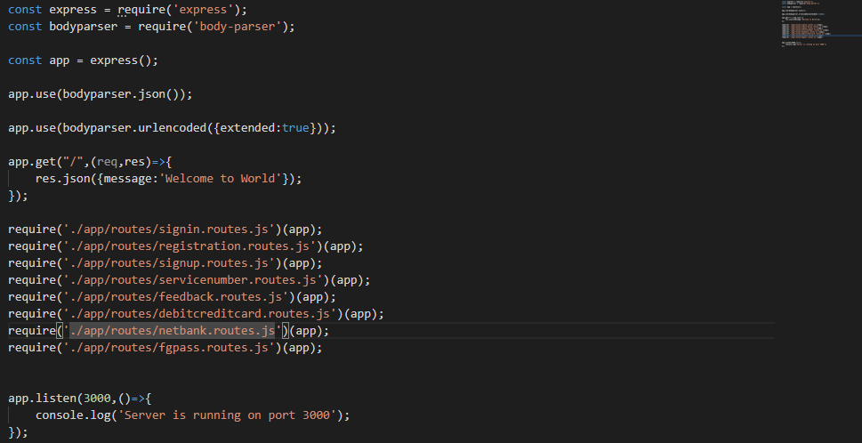

**Validations and Ajax**

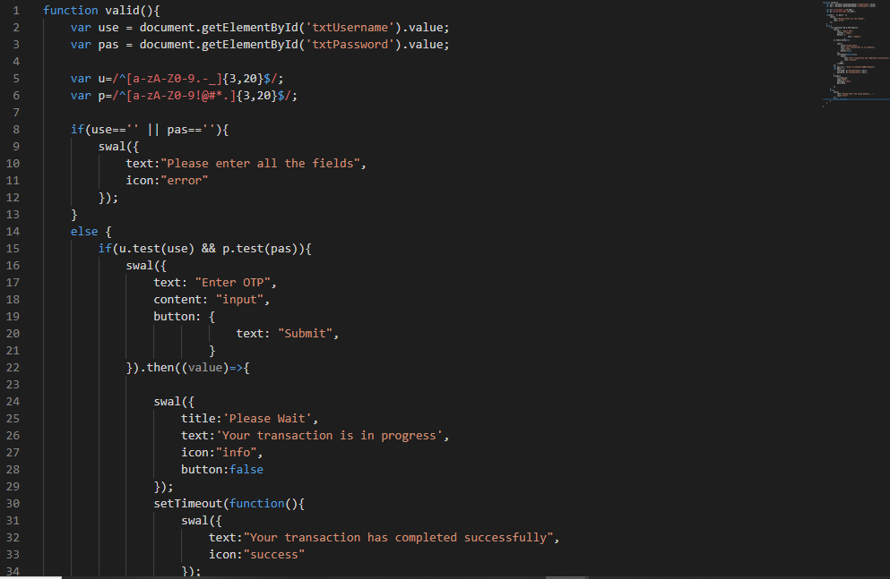

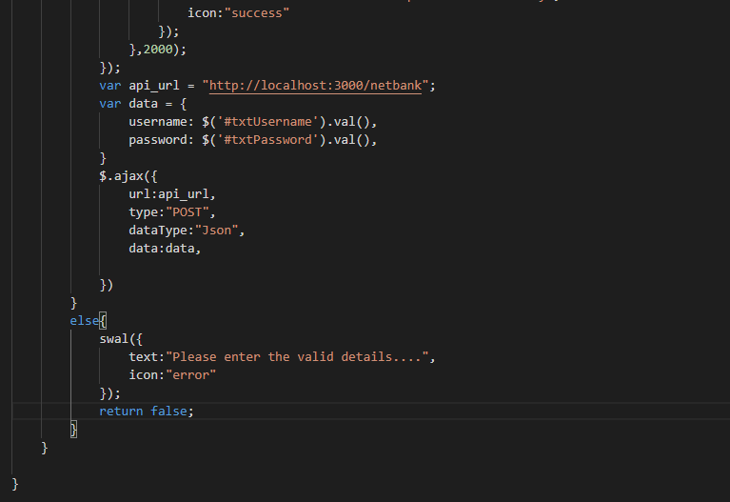

**Creating table for Netbanking**



**Output of data in Database**

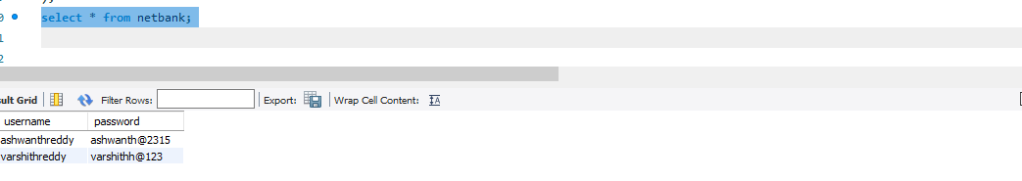

**CHAPTER-9**

**MAINTENANCE**

### 

The maintenance phase involves making changes to hardware, software, and documentation to support its operational effectiveness. It includes making changes to improve a system’s performance, correct problems, enhance security, or address user requirements. To ensure modifications do not disrupt operations or degrade a system’s performance or security, organizations should establish appropriate change management standards and procedures.

Routine changes are not as complex as major modifications and can usually be implemented in the normal course of business. Routine change controls should include procedures for requesting, evaluating, approving, testing, installing, and documenting website modifications. Maintaining accurate, up-to-date hardware and software inventories is a critical part of all change management processes. Management should carefully document all modifications to ensure accurate system inventories. Management should coordinate all technology related changes through an oversight committee and assign an appropriate party responsibility for administering software patch management programs. Quality assurance, security, audit, regulatory compliance, network, and end-user personnel should be appropriately included in change management processes. Risk and security review should be done whenever a system modification is implemented to ensure controls remain in place.

For maintenance of the website:

1. The database has to be updated regularly according to new available information.
2. Redundant and false information must be removed from the database.
3. Newer versions of PHP and MYSQL can be used for up gradation of website and to improve the overall performance of the system.

**CHAPTER-10**

**FUTURE SCOPE AND FUTURE ENHANCEMENT**

**PROJECT NAME:** ONLINE BROADBAND INTERNET SERVICES

**CONCLUSION**

### 

**CHAPTER-11**

We have successfully implemented the site ‘KAPS BROADBAND SERVICES’. With the help of various links and tools, we have been able to provide a site which will be live soon and running on the web. We have been successful in our attempt to take care of the needs of both the user as well as the administrator. Finally, we hope that this will go a long way in popularizing.

**BIBLIOGRAPHY**

1. [www.javatutpoint.com](http://www.javatutpoint.com/)
2. [www.w3schools.com](http://www.w3schools.com/)
3. [www.getbootstrap.com](http://www.getbootstrap.com/)
4. [www.codeigniter.com](http://www.codeigniter.com/)
5. [www.stackoverflow.com](http://www.stackoverflow.com/)
6. [www.fontawesome.io](http://www.fontawesome.io/)
7. www.[sweetalert.js.org](https://sweetalert.js.org/docs/)
8. www.codepen.io
9. Learn HTML and CSS faster (Mark Myers)
10. Wikipedia